L1  
Python - Language Features

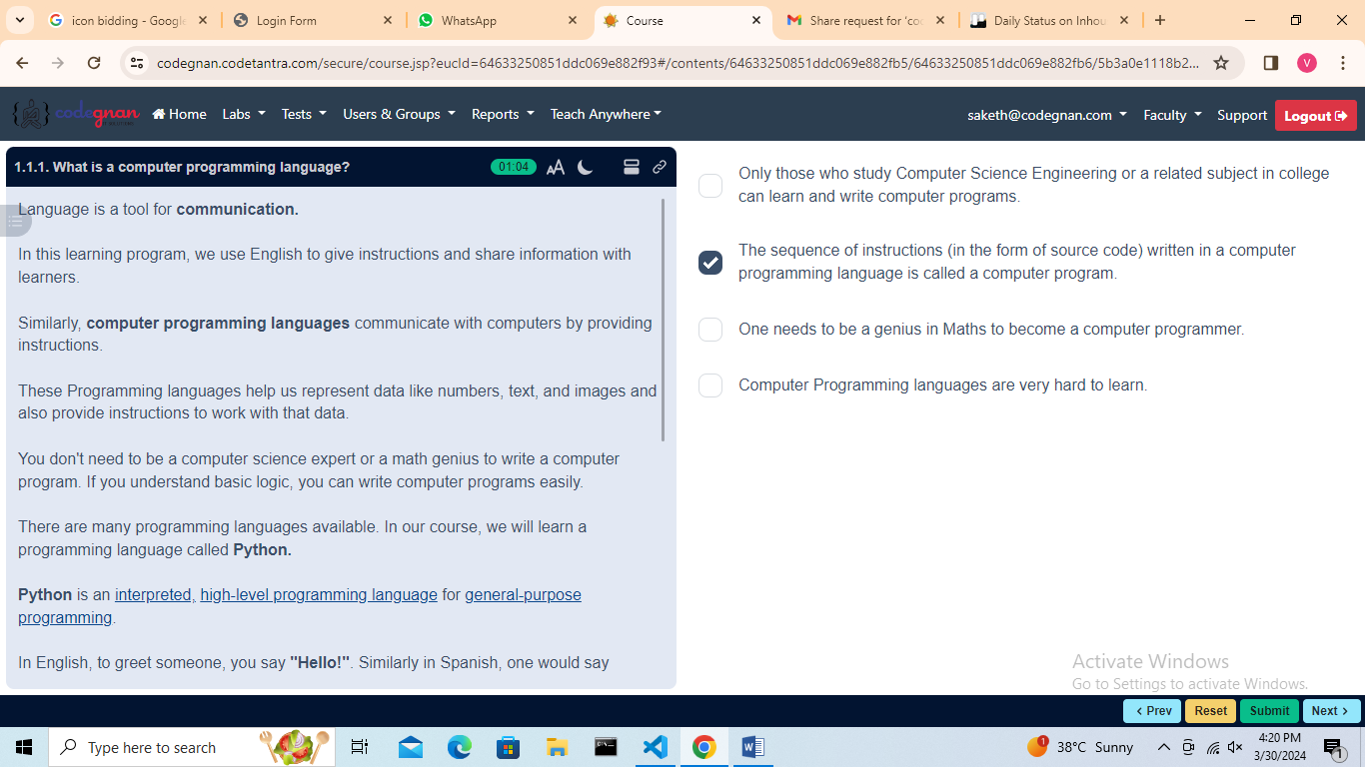

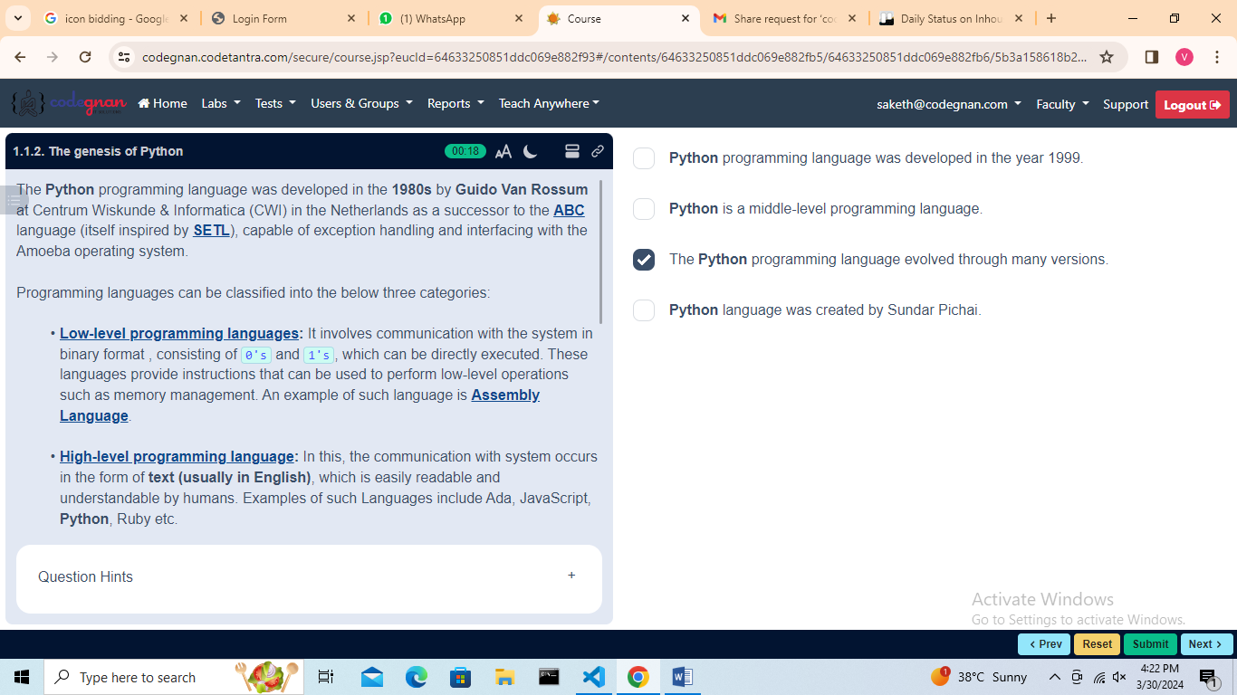

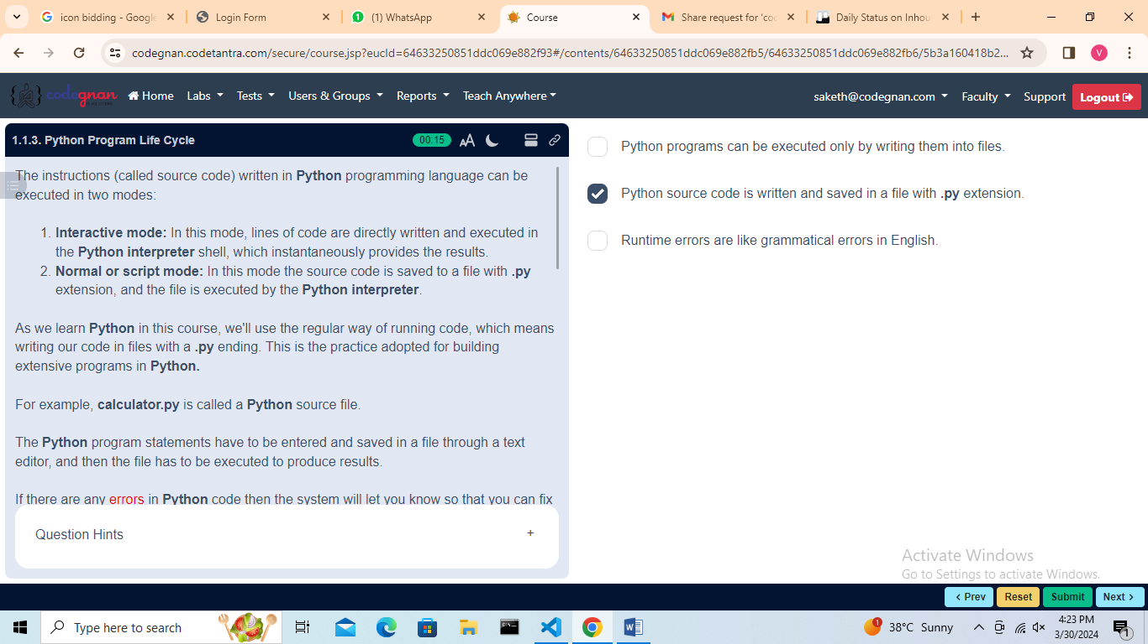

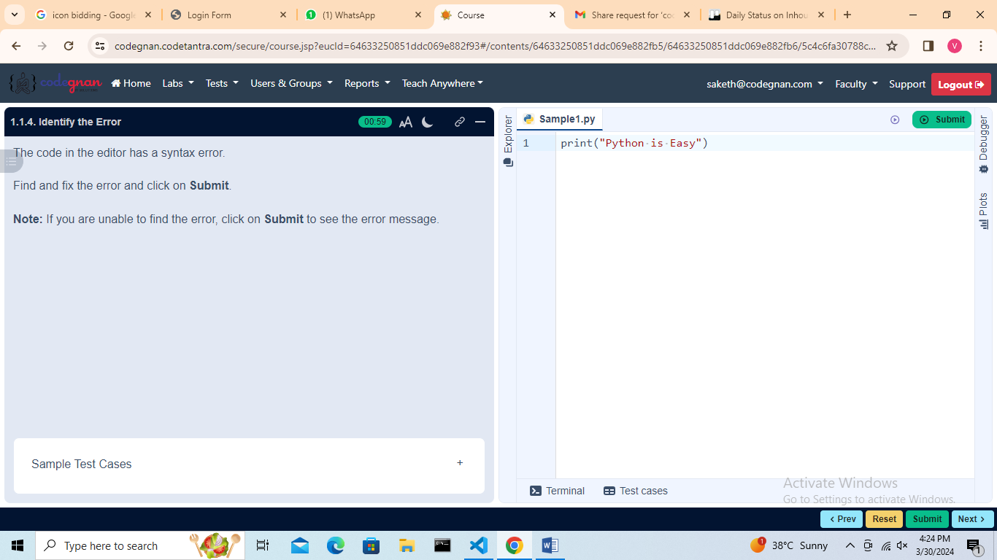

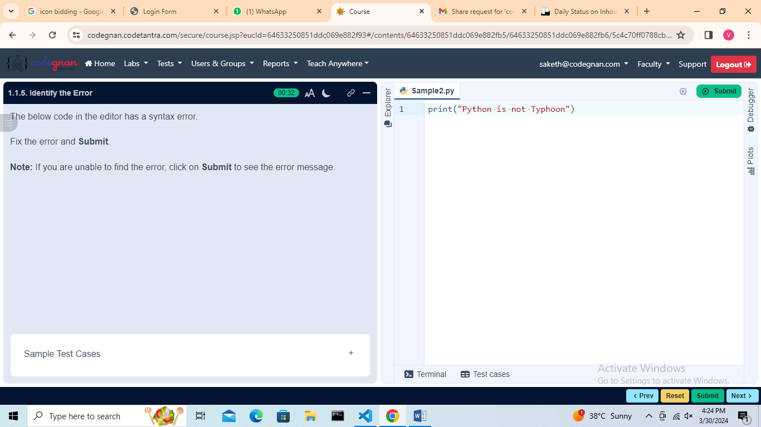

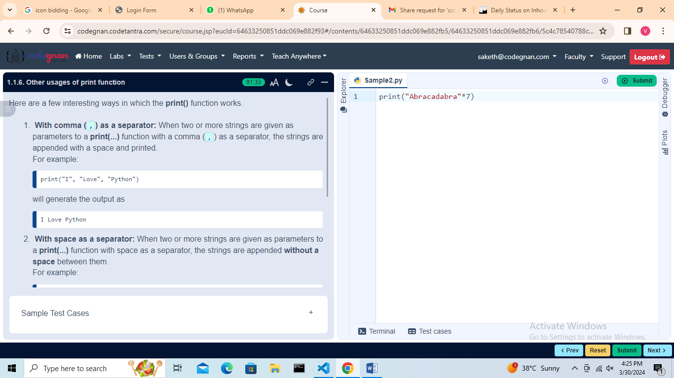

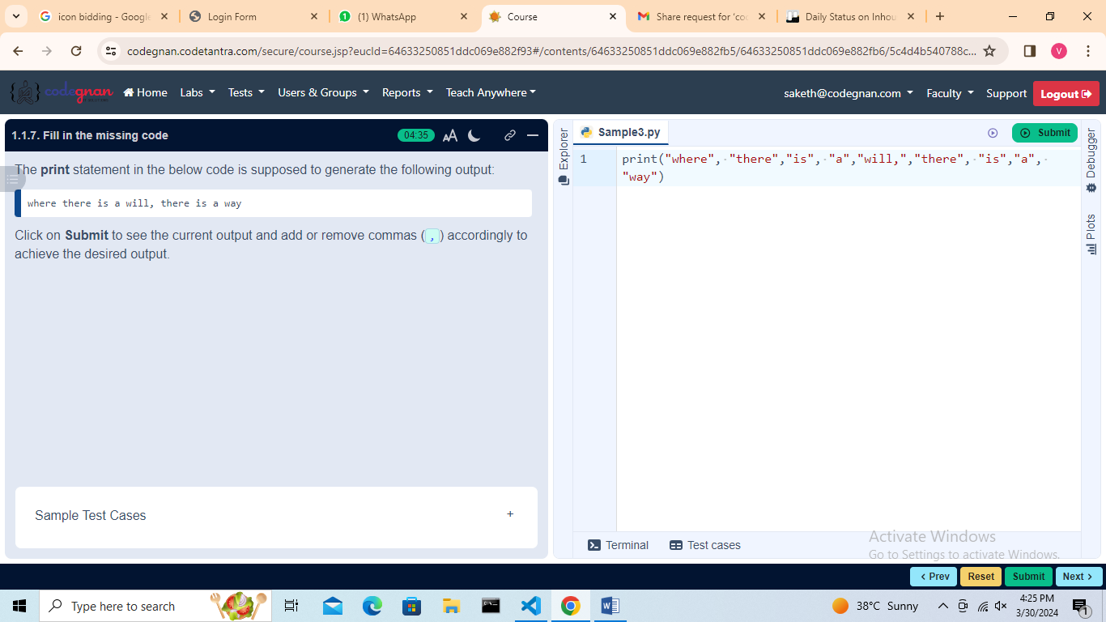

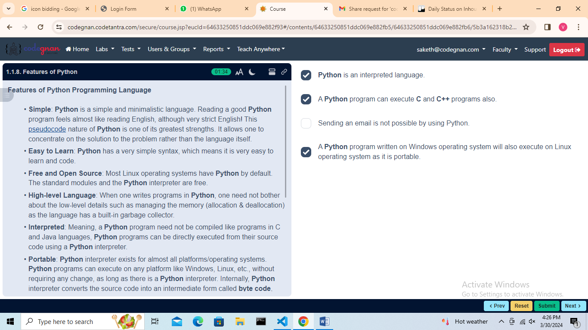

## L2 Comments

## Comments

## 

## 

## 

## Identifiers and Keywords

## 

## 

## 

L3

Variables and Assignment

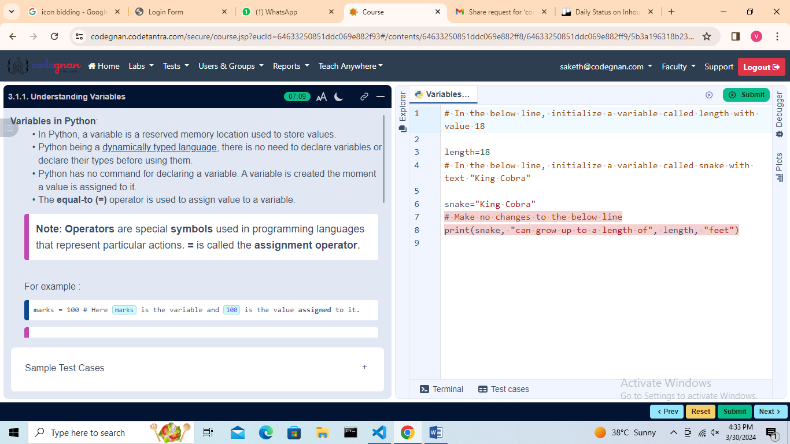

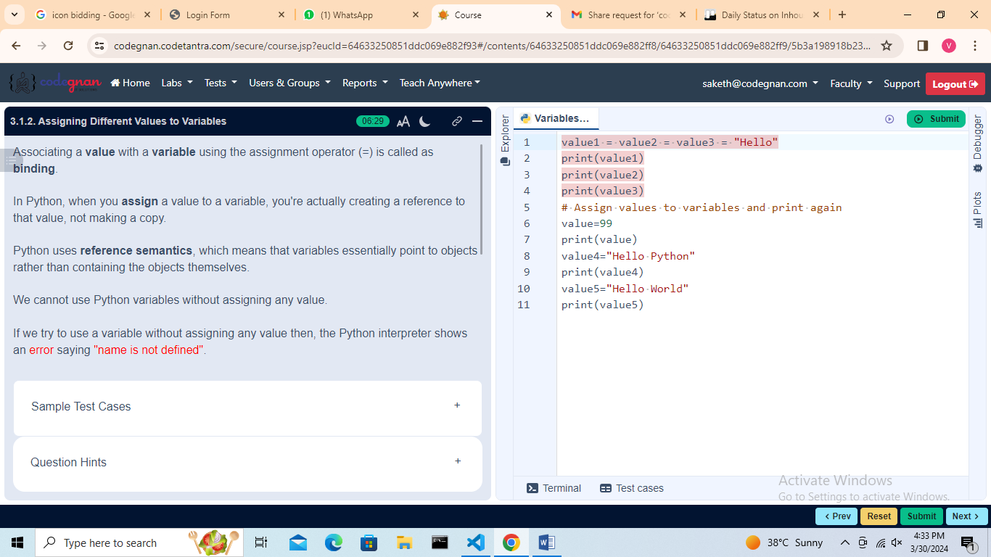

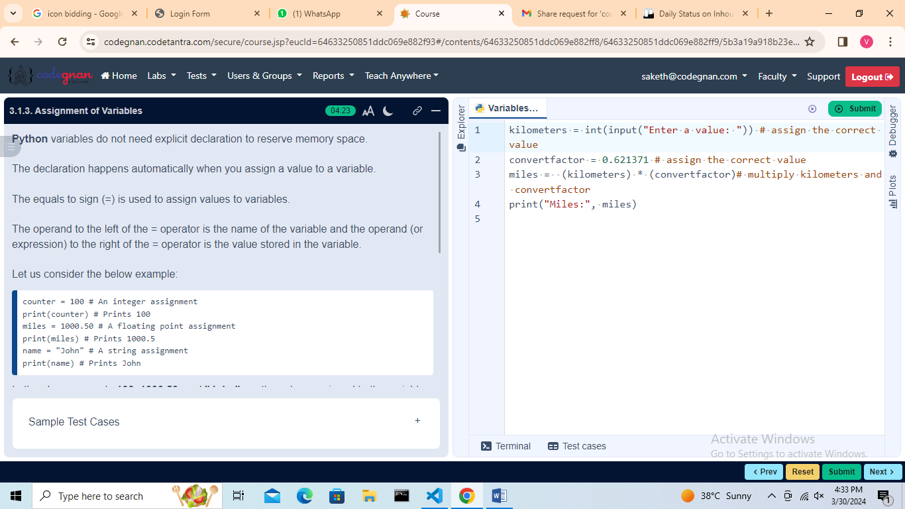

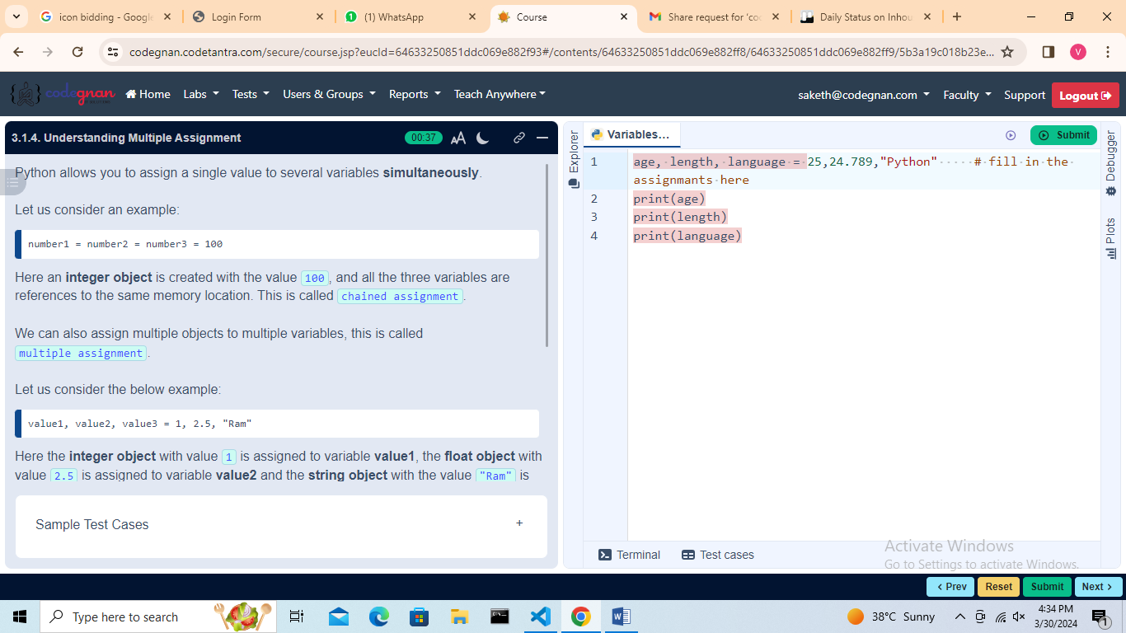

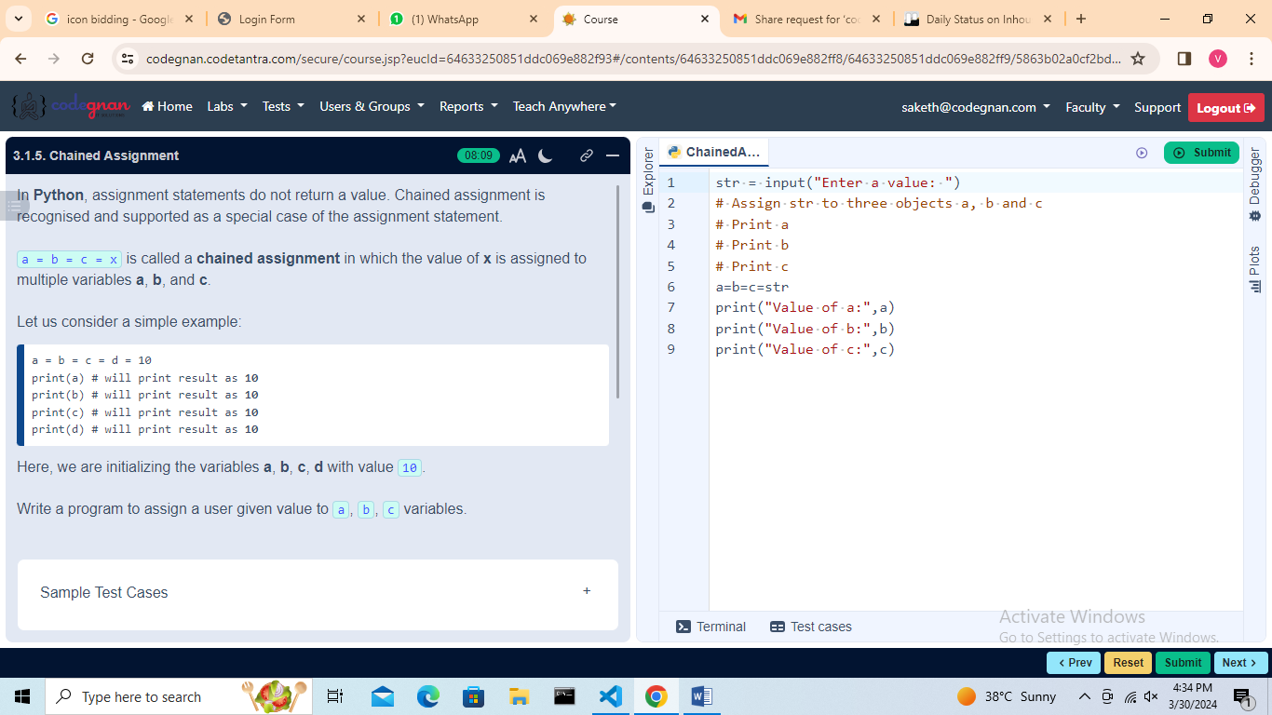

## L4

Expressions and Statements, Indentation

## 

## 

## 

## 

## Indentation

## 

## 

## L5

Data Types - Numbers, Strings

## 

## Numbers

## Strings

## 

## L6

## Lists

## 

## 

## Sets

## 

## Tuples

## 

## 

## 

## L7

Data Types - Dictionaries, Data Type Conversions

## 

## 

## 

## 

## 

## L8

Input and Output Statements, Basics of Python Programming

## 

## 

## 

## 

## 

## Basics of Python Programming

## 

## 

## L9

Arithmetic Operators, Comparison Operators

## 

## 

## 

## 

## 

## 

## Comparison Operators

## 

## 

## 

## 

## L10

Assignment Operators

## 

## 

## 

## Bitwise Operators

## 

## 

## 

## 

## 

## 

## 

## L11

Logical Operators, Membership Operators

## 

## 

## 

## 

## 

## Membership Operators

## 

## 

## 

## 

## L12

Identity Operators, Operators Precedence

## 

## 

## 

## 

## Operators Precedence

## 

## 

## 

## 

## 

## L13

Practice Programs - Operators

## 

## 

## 

## L14

Introduction to Algorithms

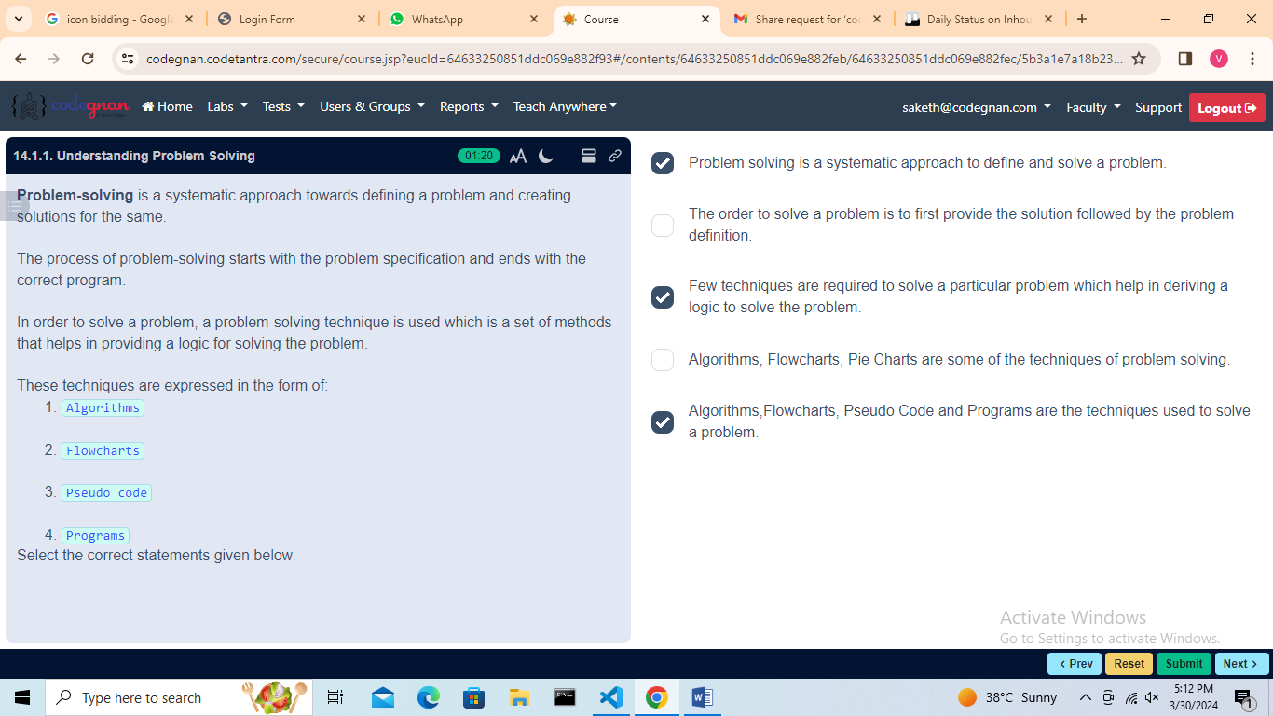

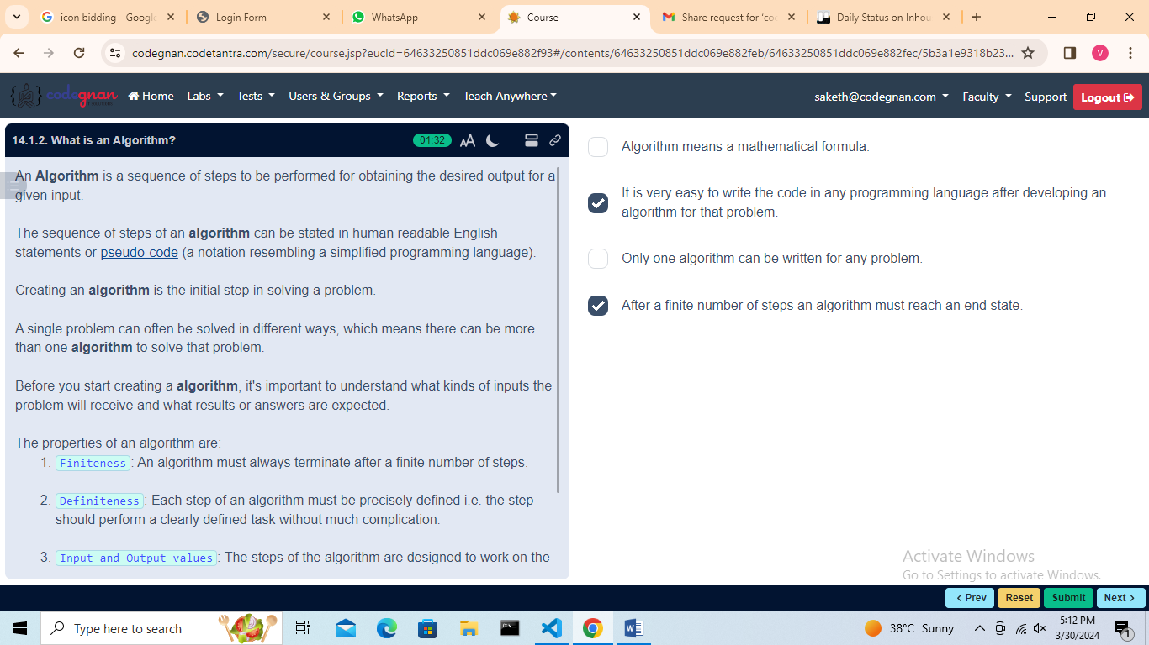

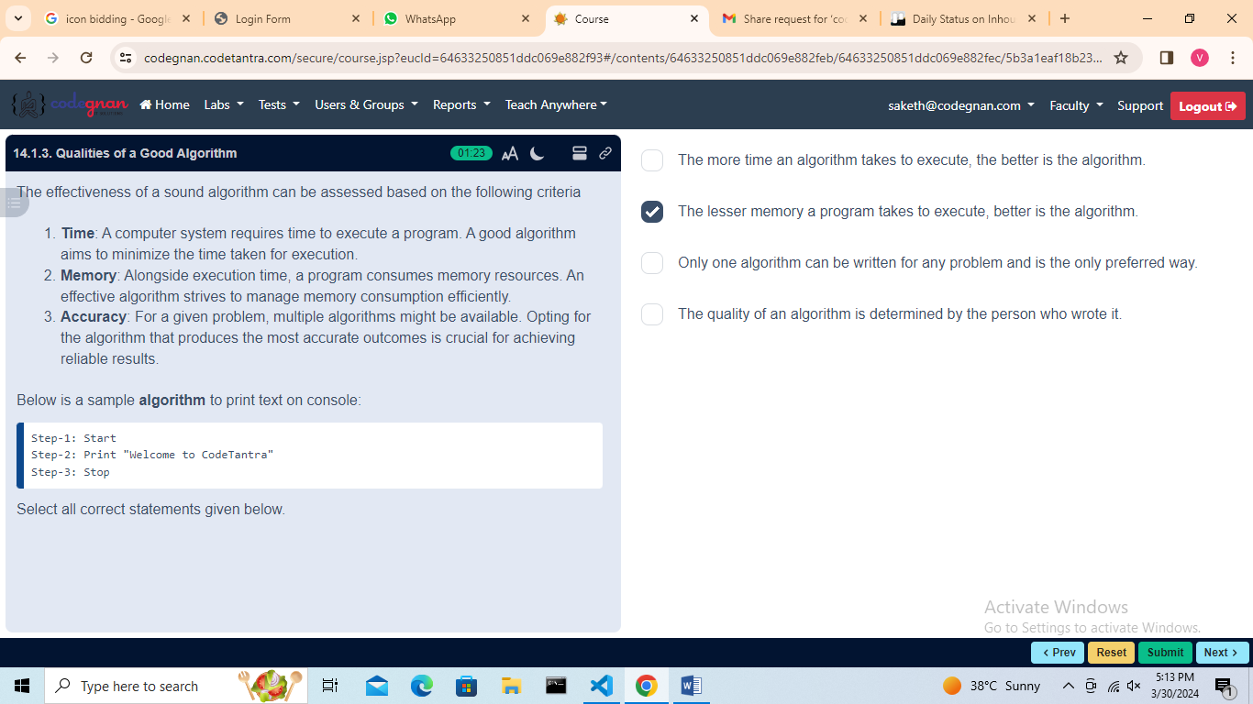

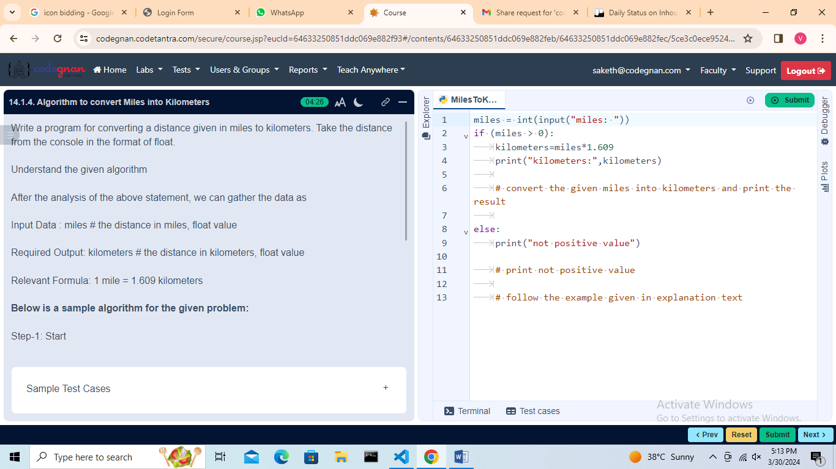

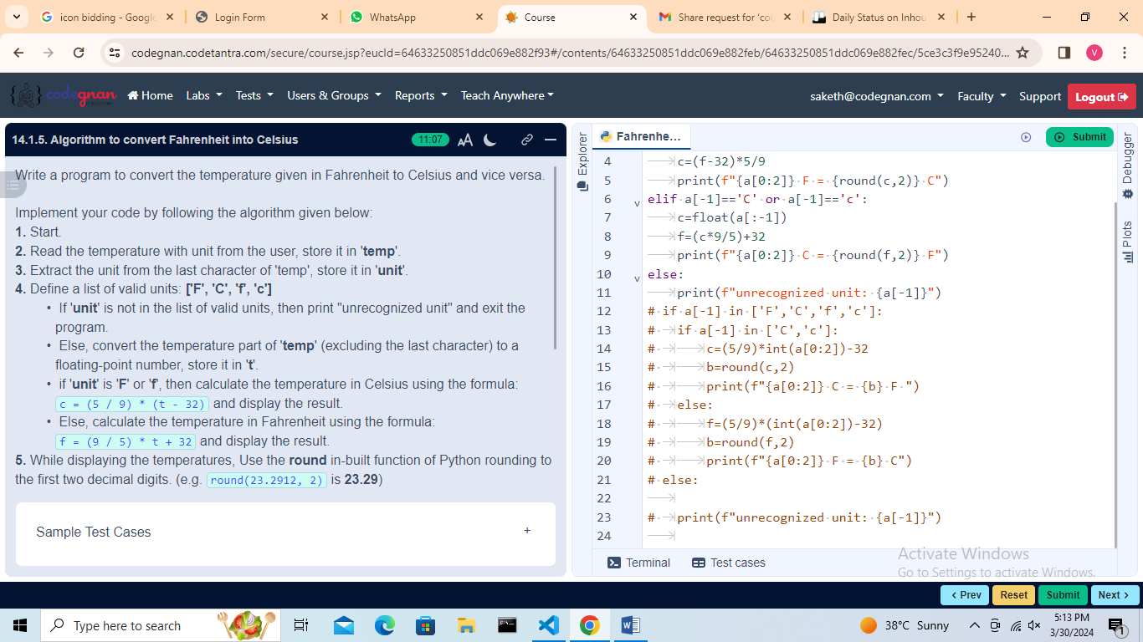

## L15

Building Blocks of Algorithms

## 

## 

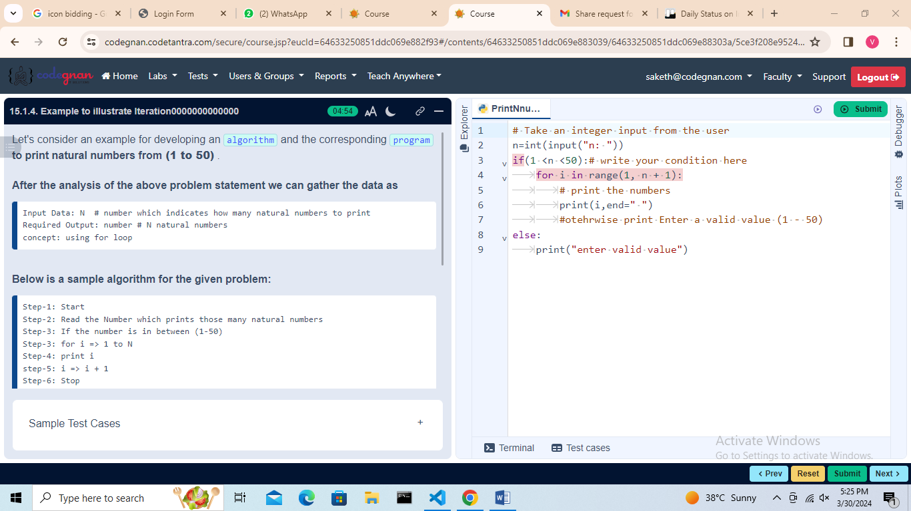

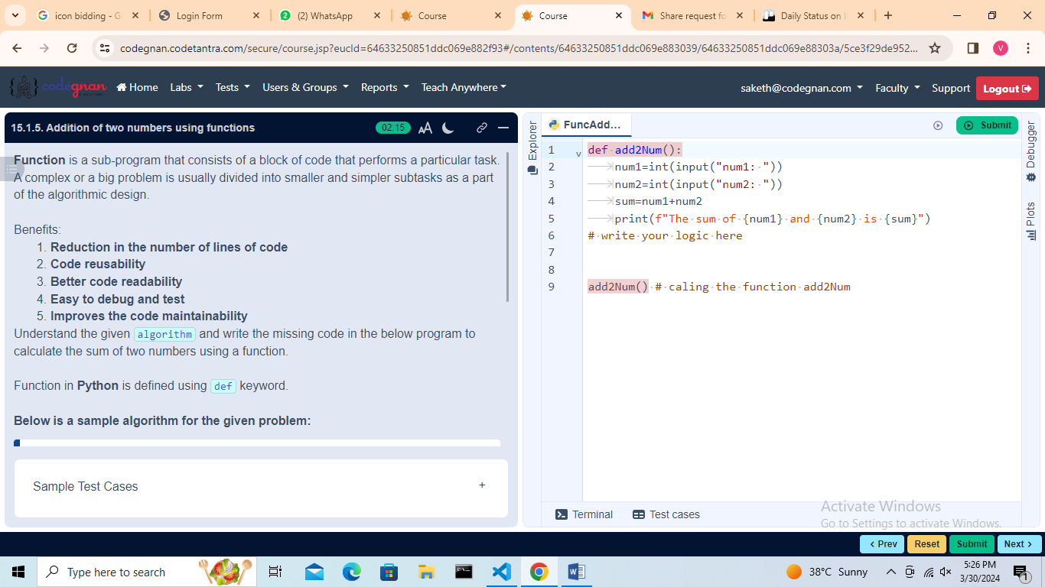

## L16

Pseudo Code and Flow Charts

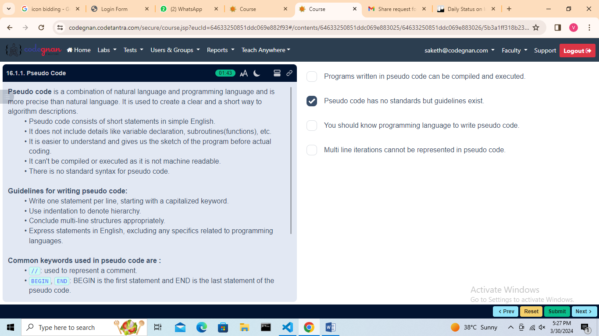

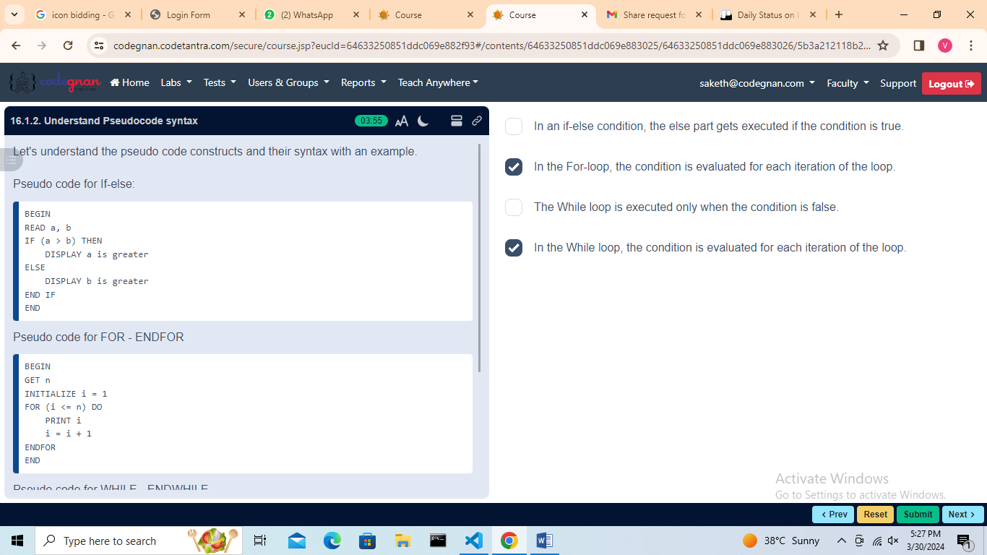

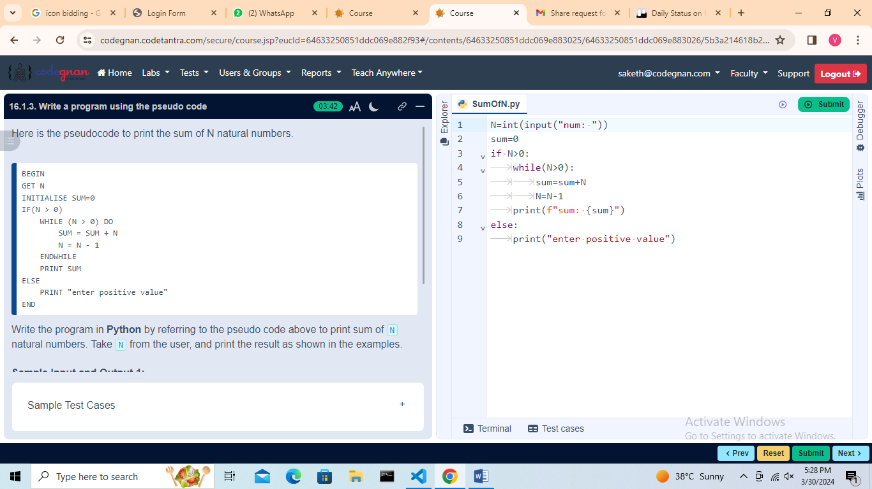

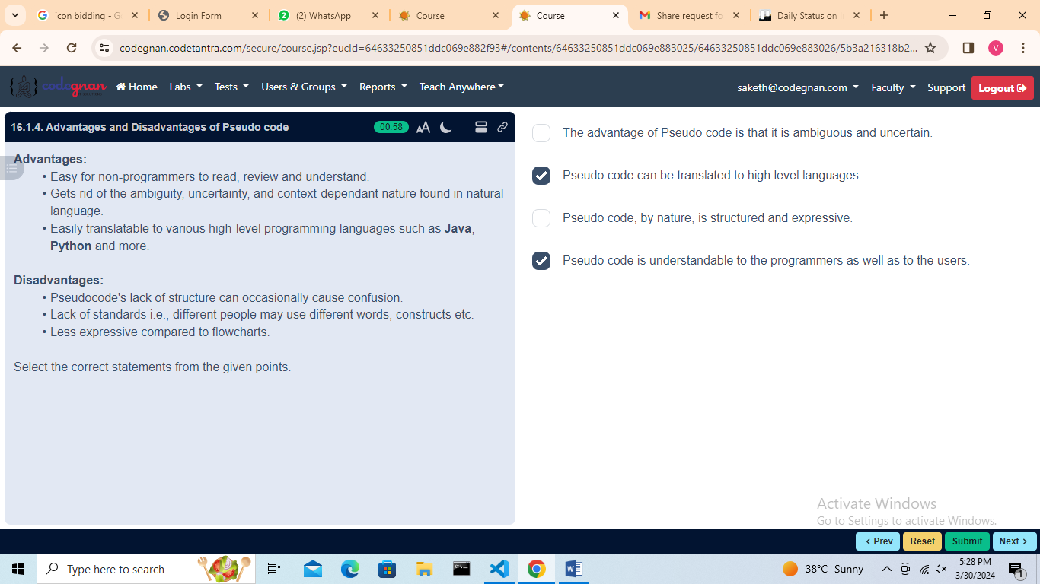

## Flow Charts

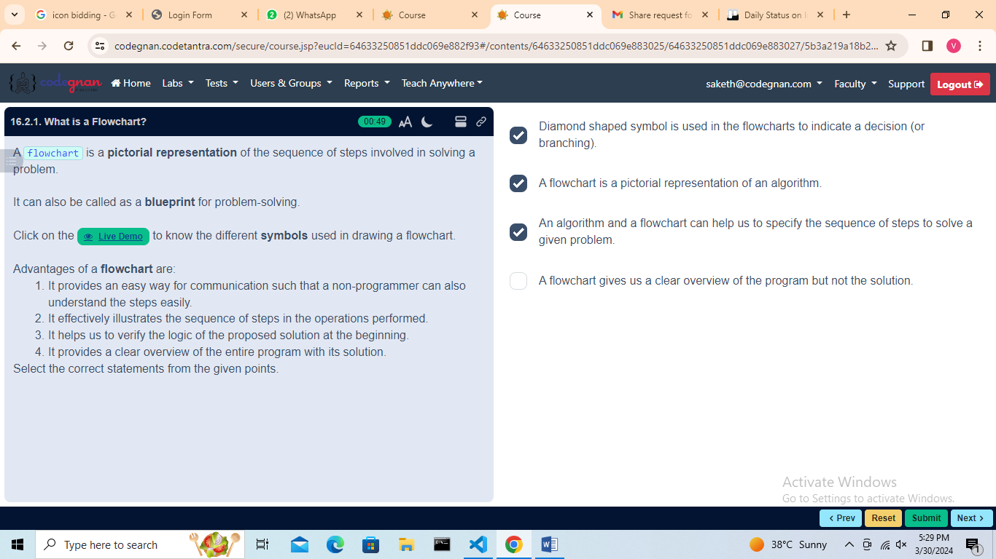

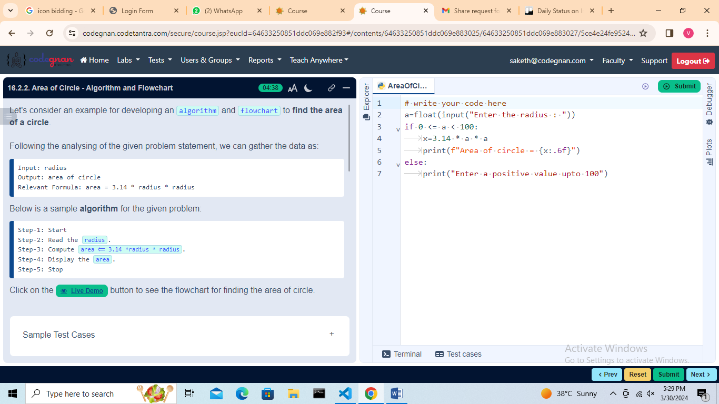

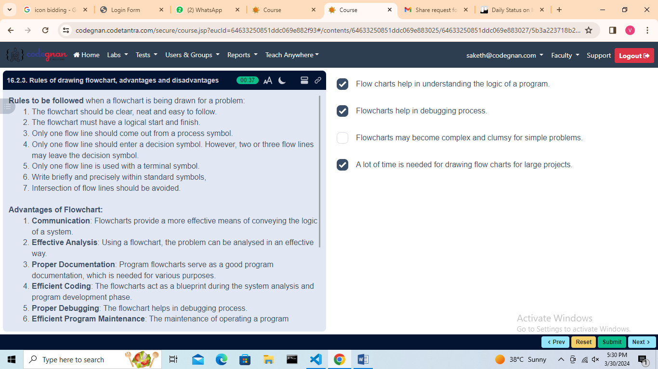

## L17

## Programming Language

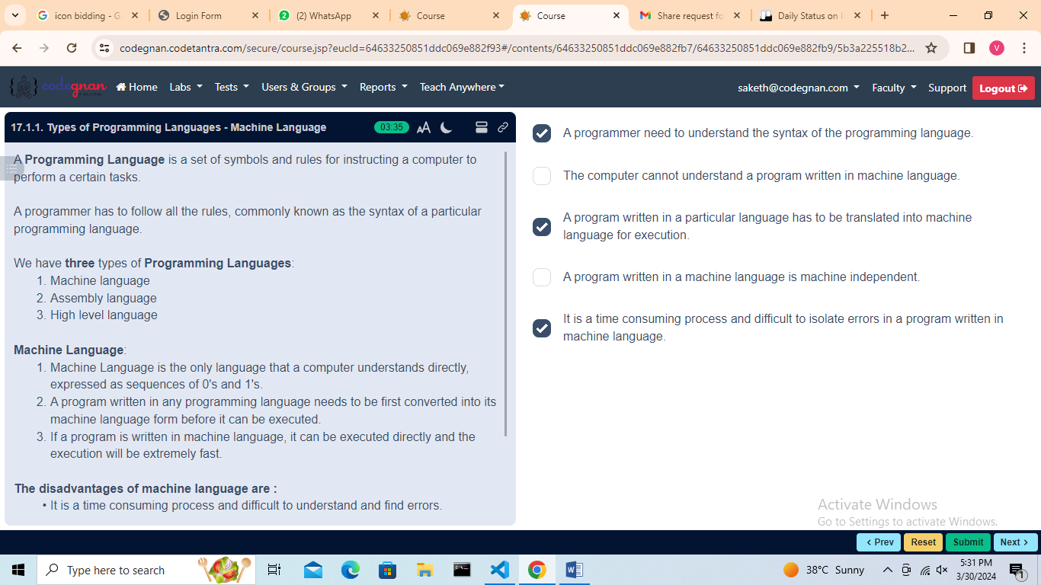

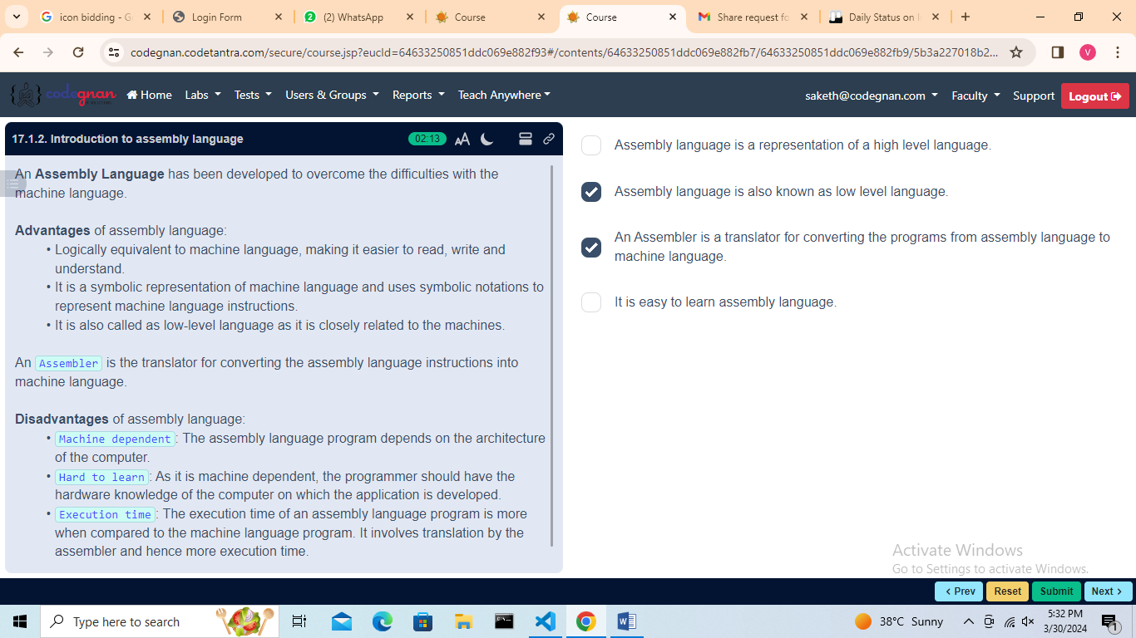

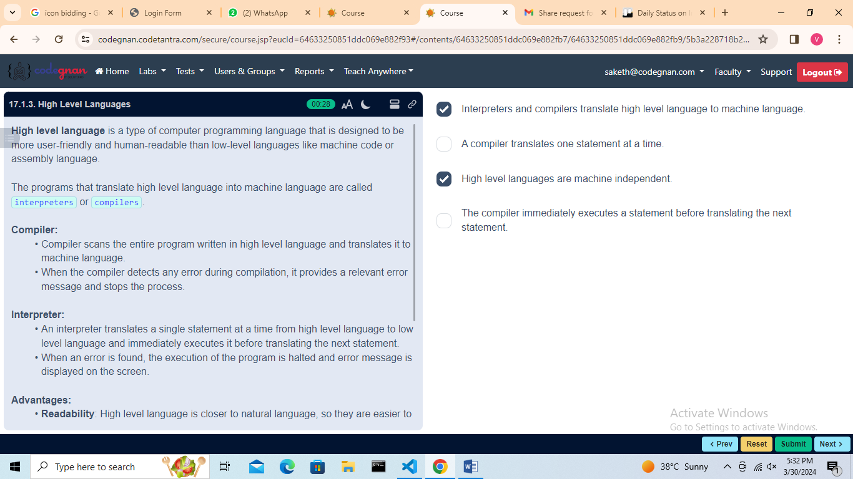

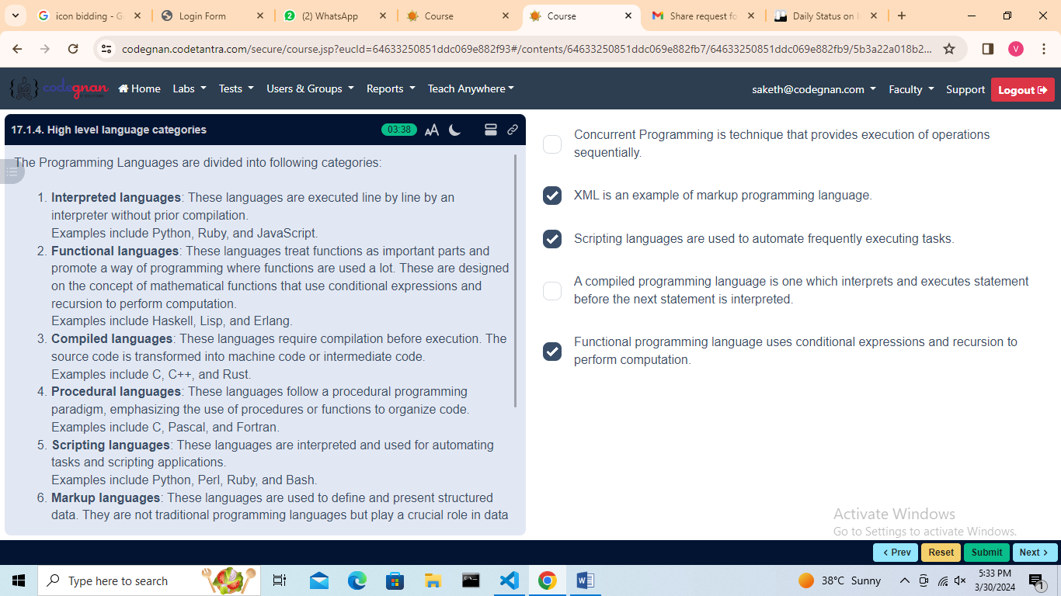

## Algorithmic Problem Solving

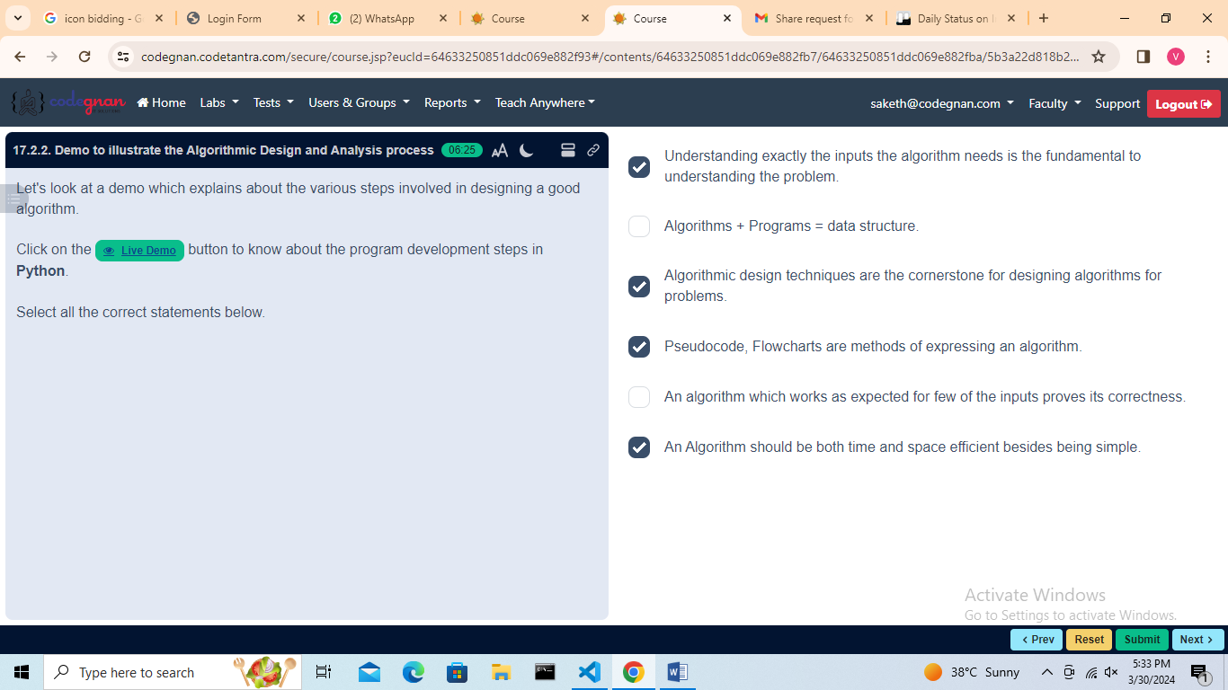

## Simple Strategies for Developing Algorithms

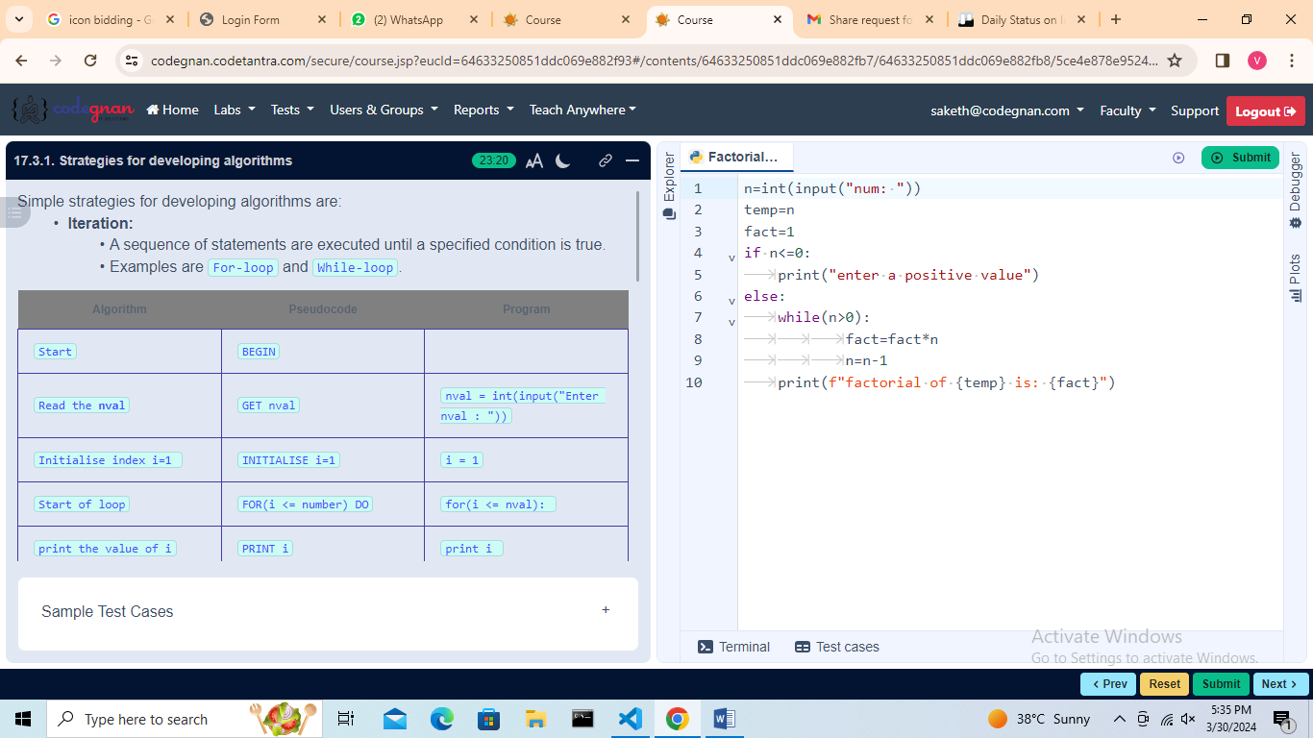

## L18

## Problem Solving Exercise - Algorithms

## 

## 

## 

## 

## L19

If Statement

## 

## 

## 

## L20

If-else Statement

## 

## 

## 

## 

## L21

If-elif-else Statement

## 

## 

## 

## L22

While Loop  
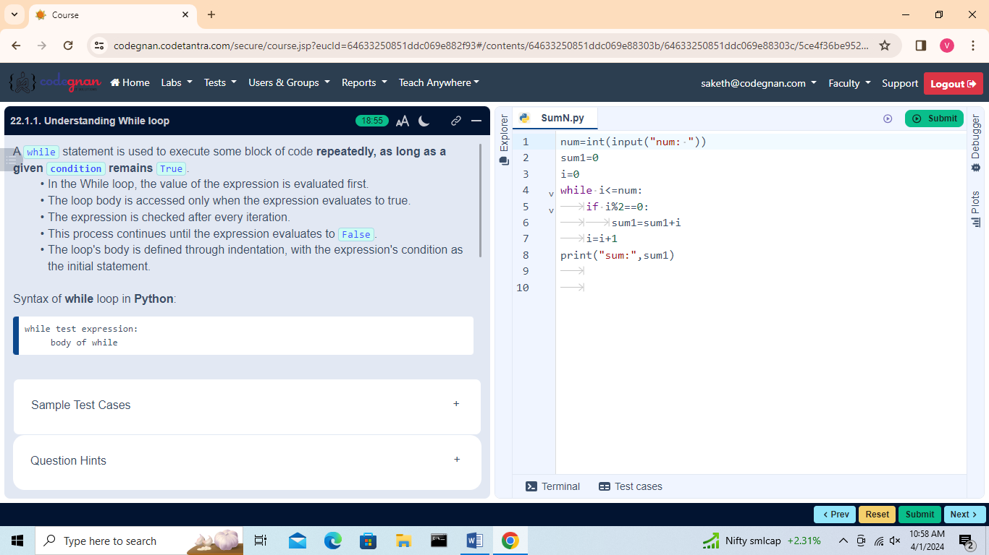

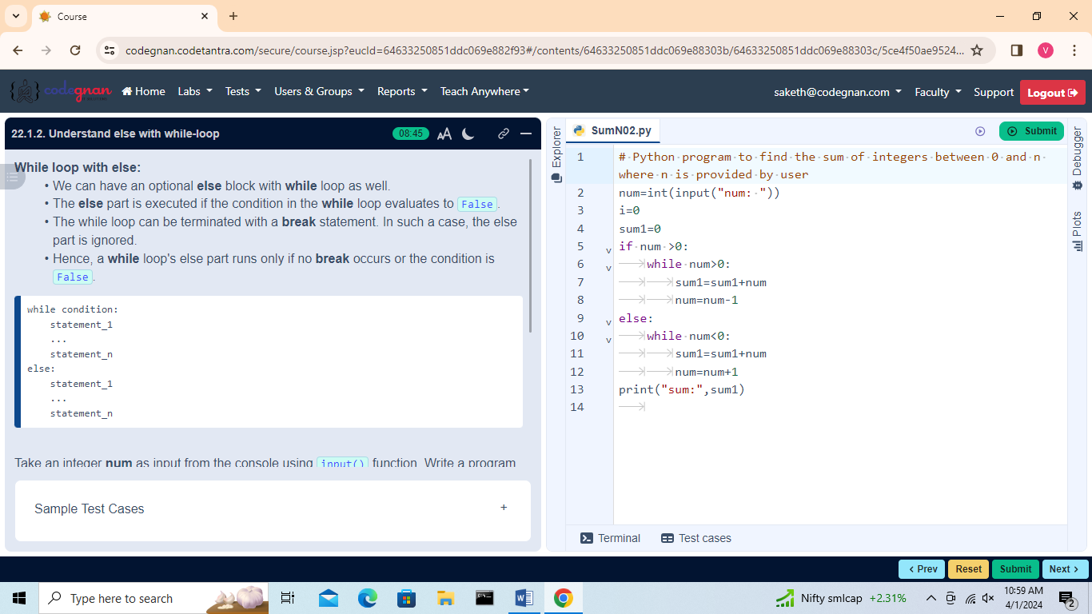

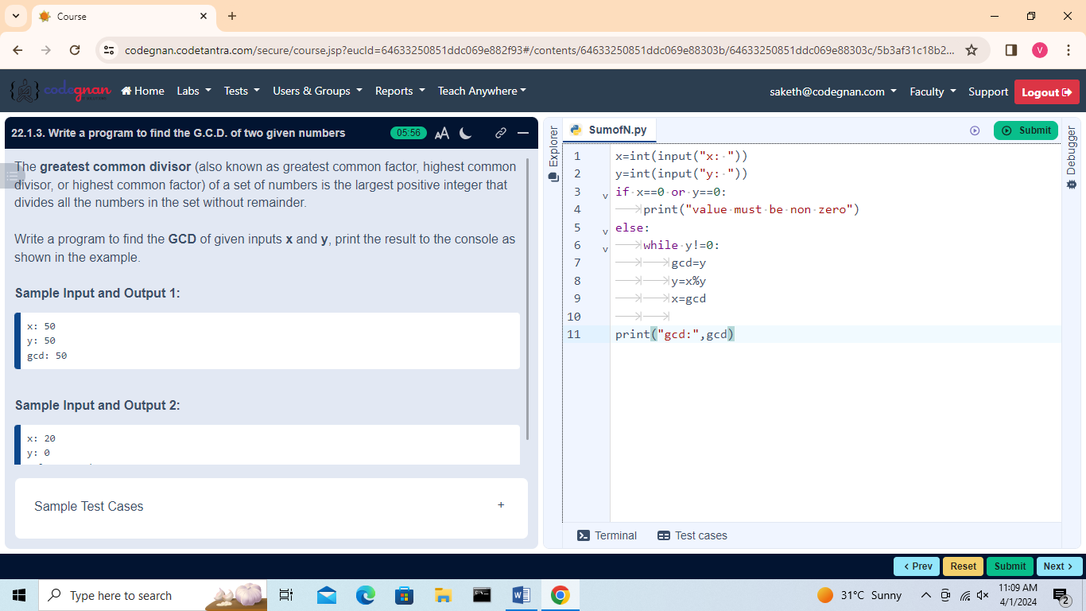

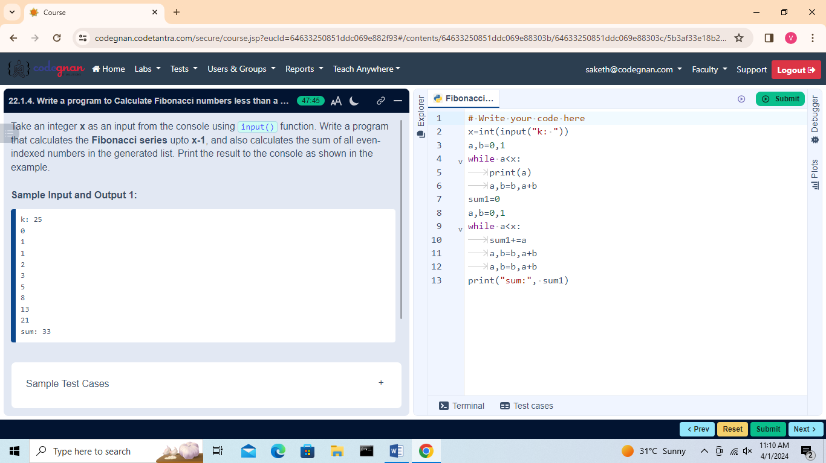

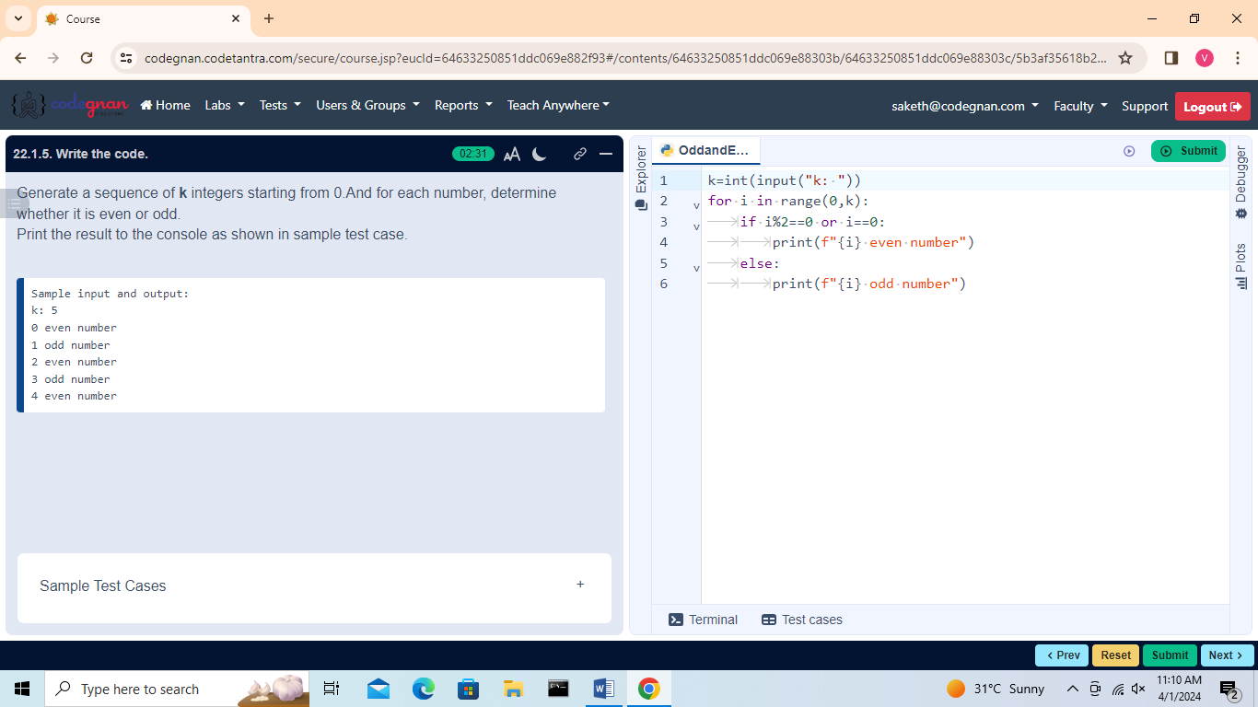

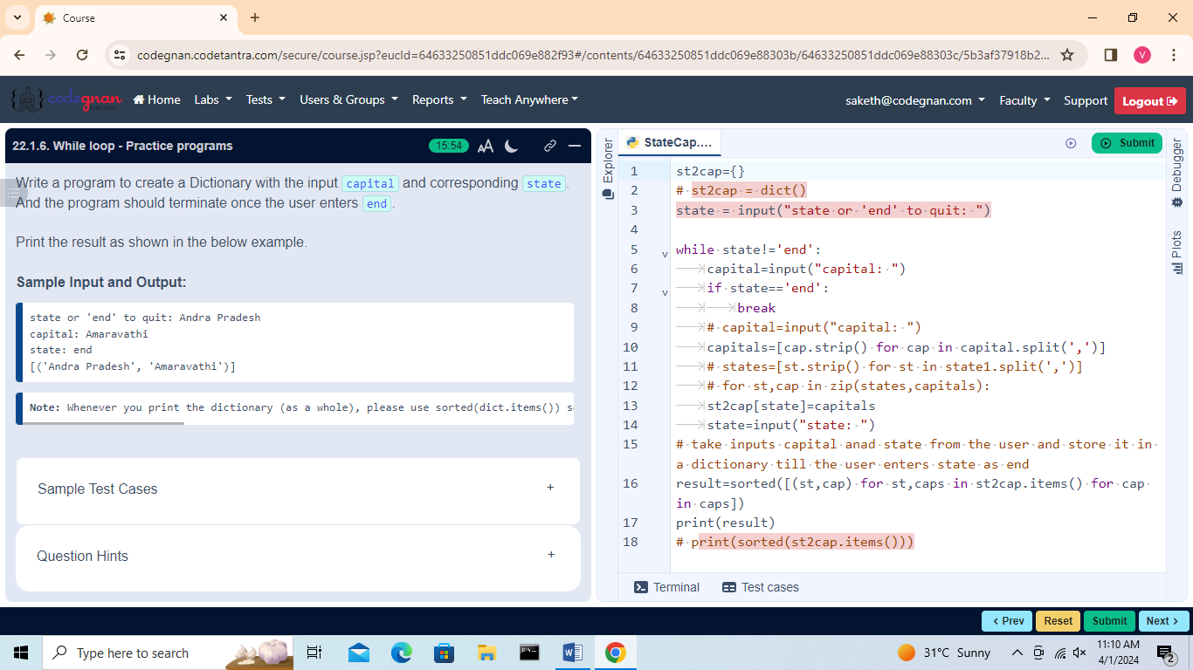

## L23

For Loop

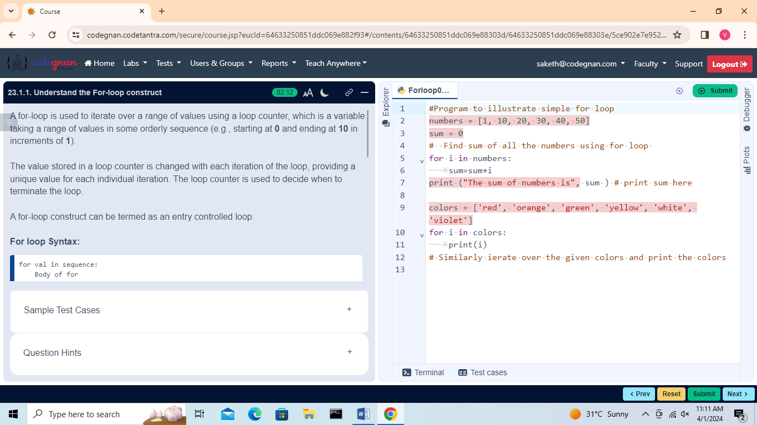

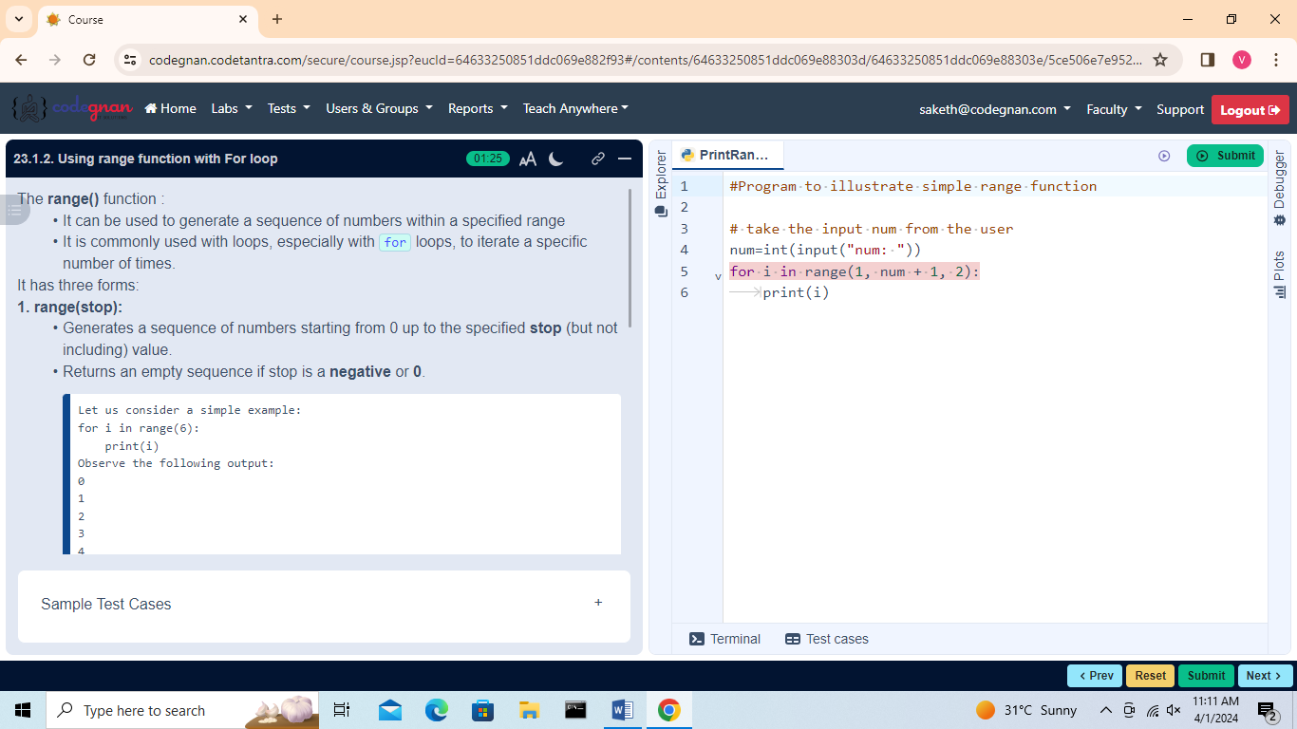

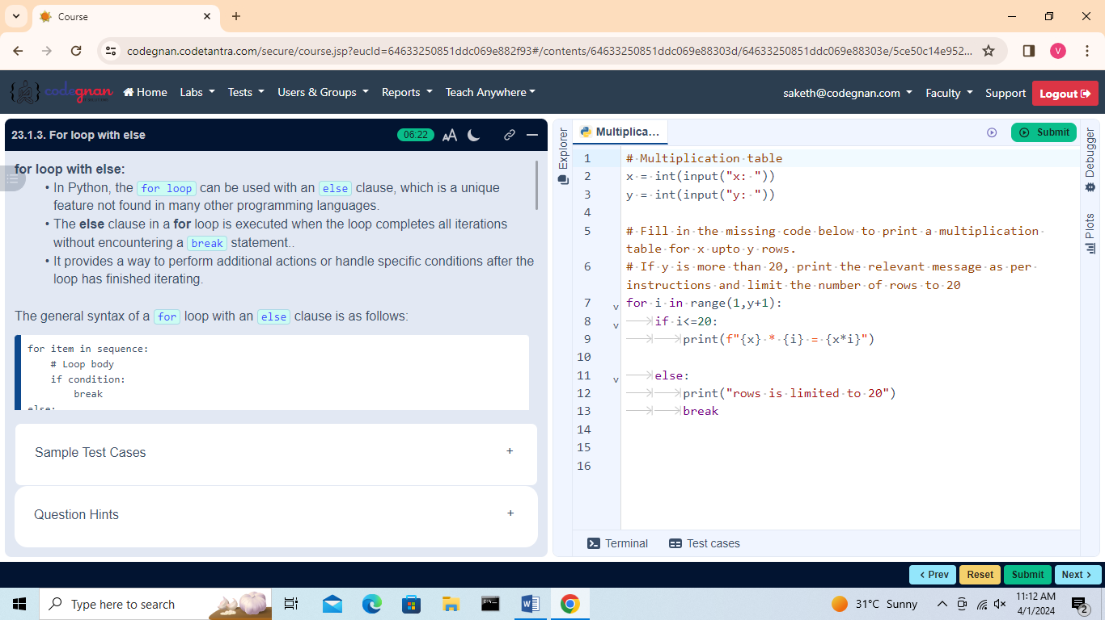

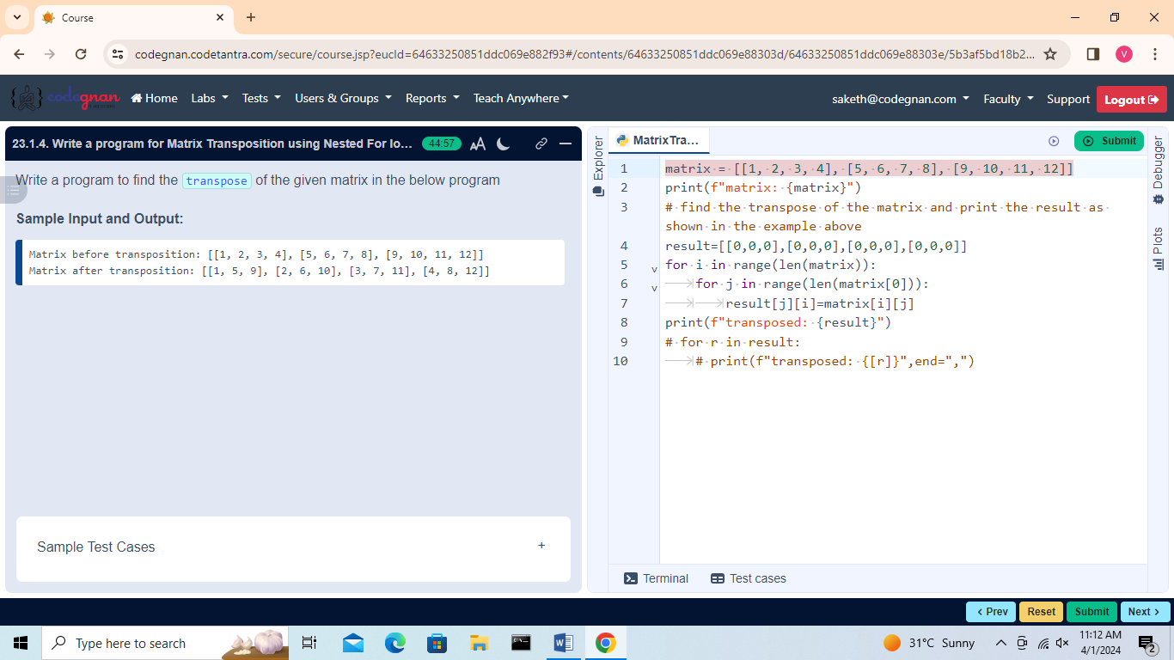

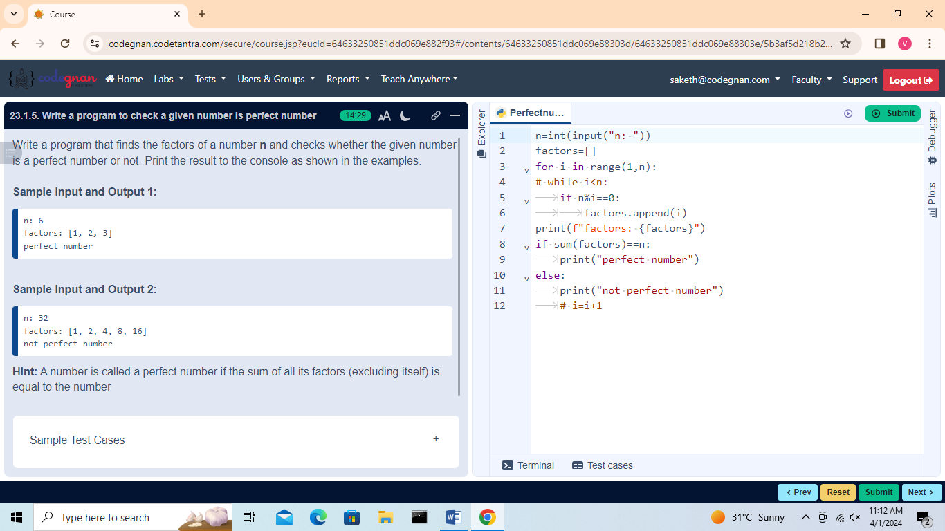

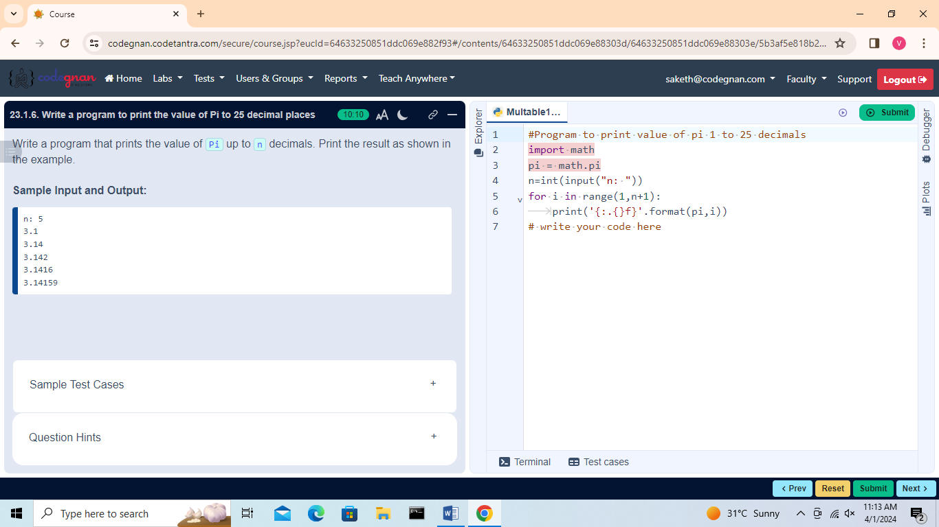

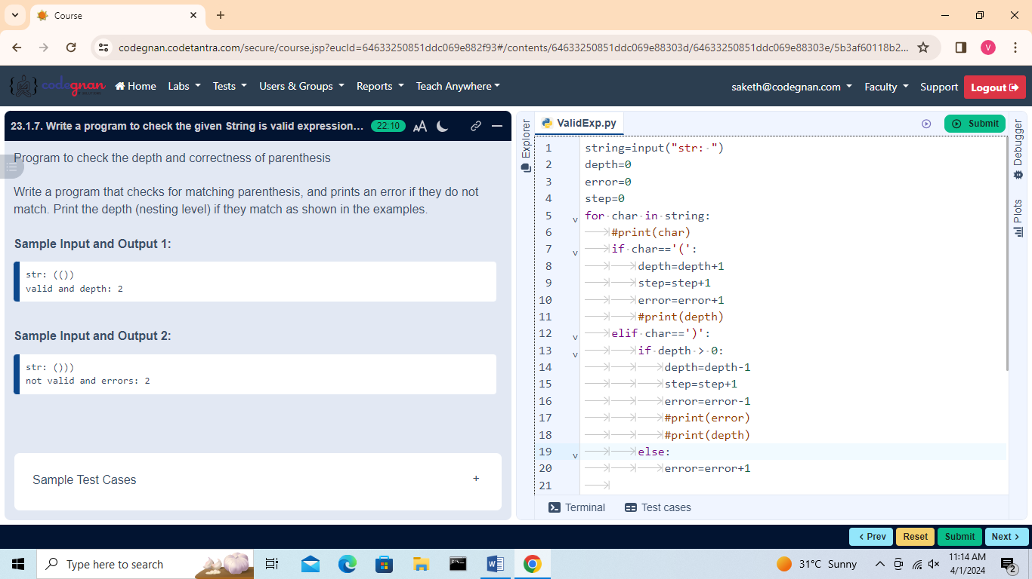

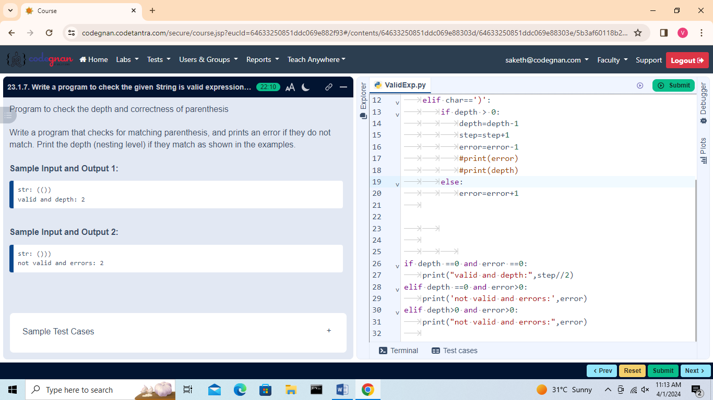

## L24

## Break Statement

## 

## 

## 

## L25

## 

## L26

## Pass Statement

## 

## L27

## Control Statements

## 

## 

## 

## 

## 

## 

## L28

Introduction to Numbers, Number Type Conversion

## 

## 

## Number Type Conversion

## 

## 

## L29 Mathematical Functions, Random Number Functions

## 

## Random Number Functions

## 

## L30 Trigonometric Functions, Mathematical Constants

## 

## Mathematical Constants

## 

## 

## L31

Introduction to Strings, String Operations  
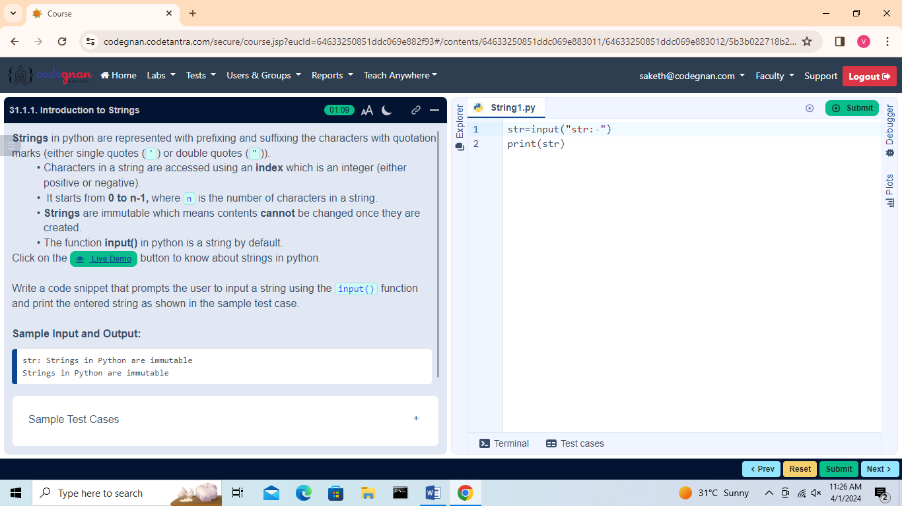

## String Operations

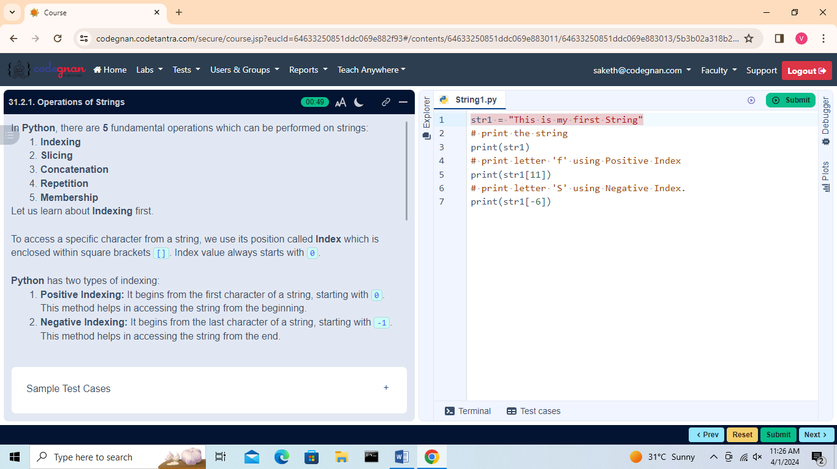

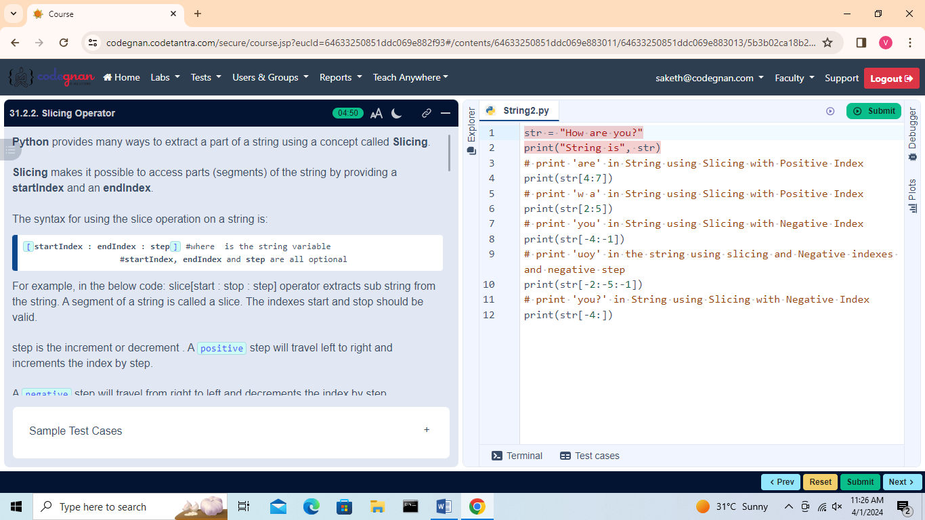

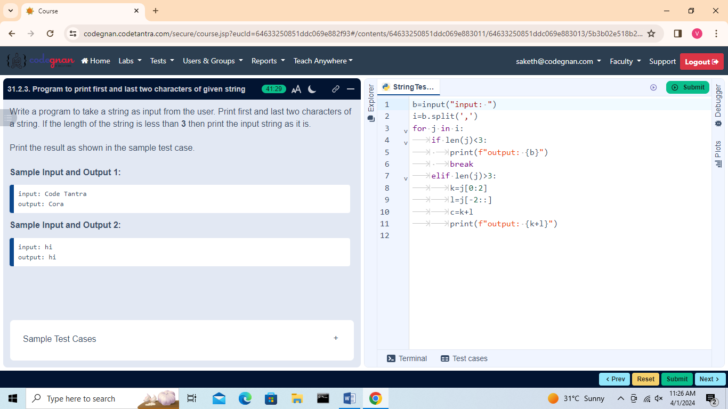

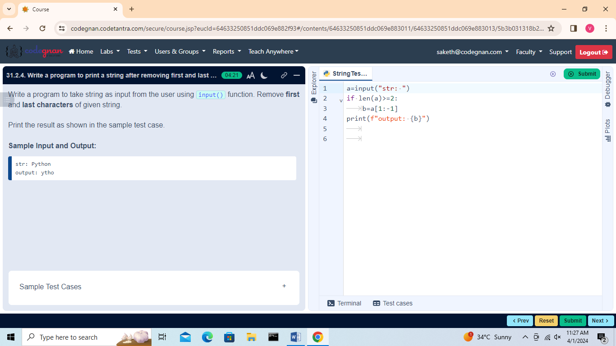

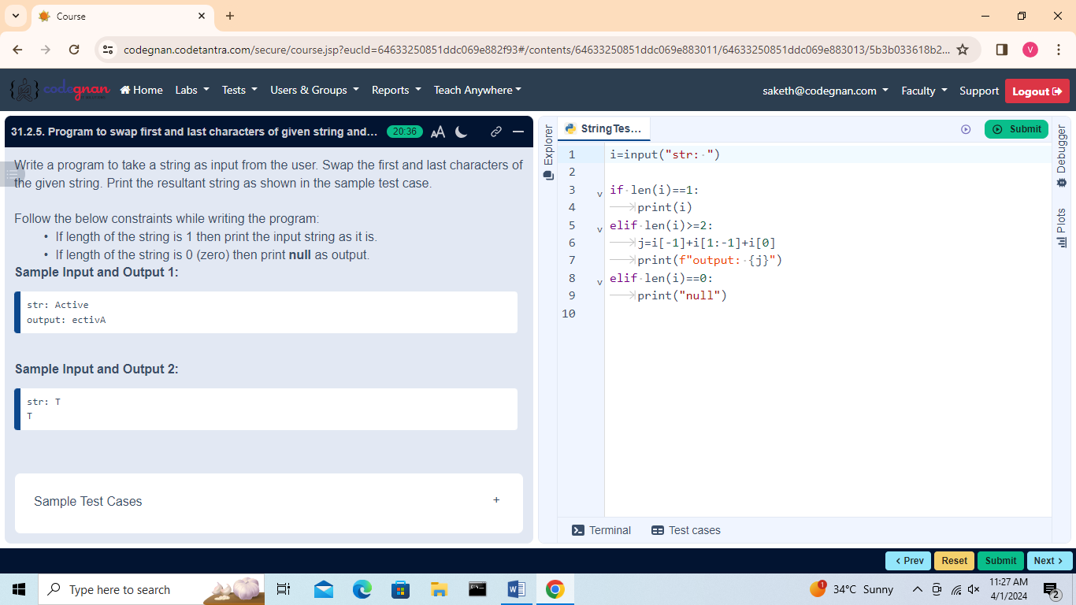

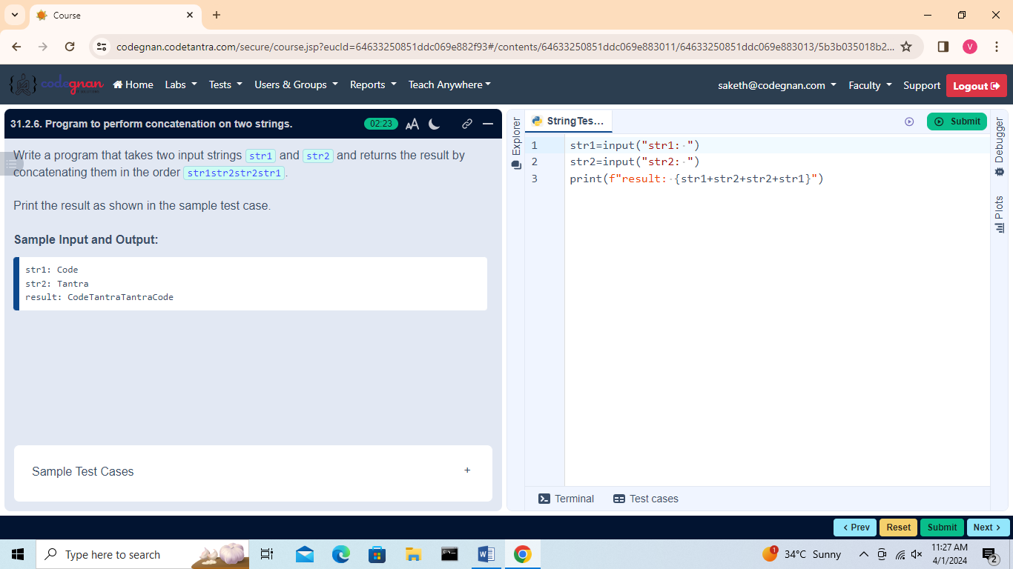

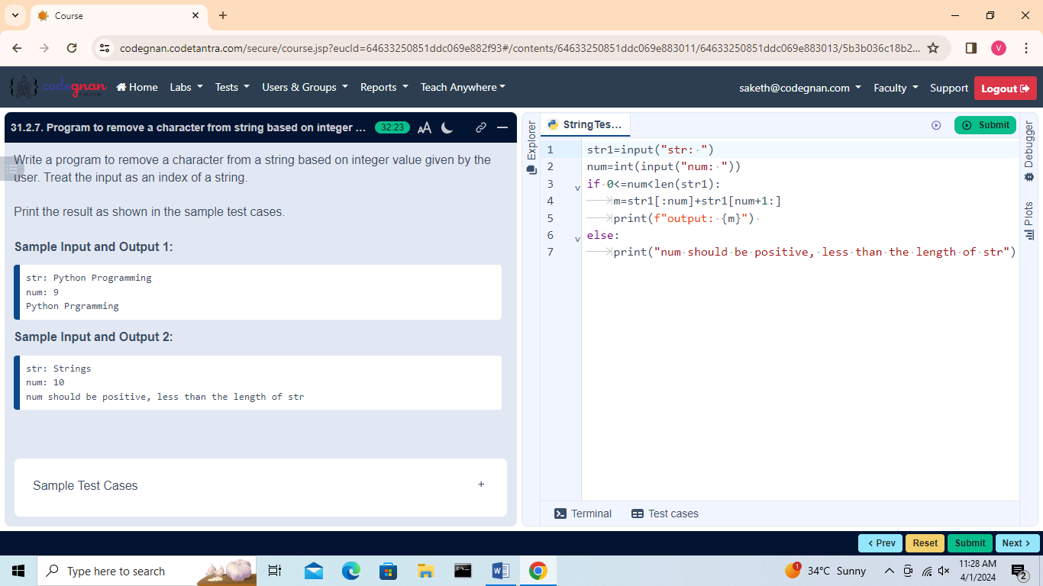

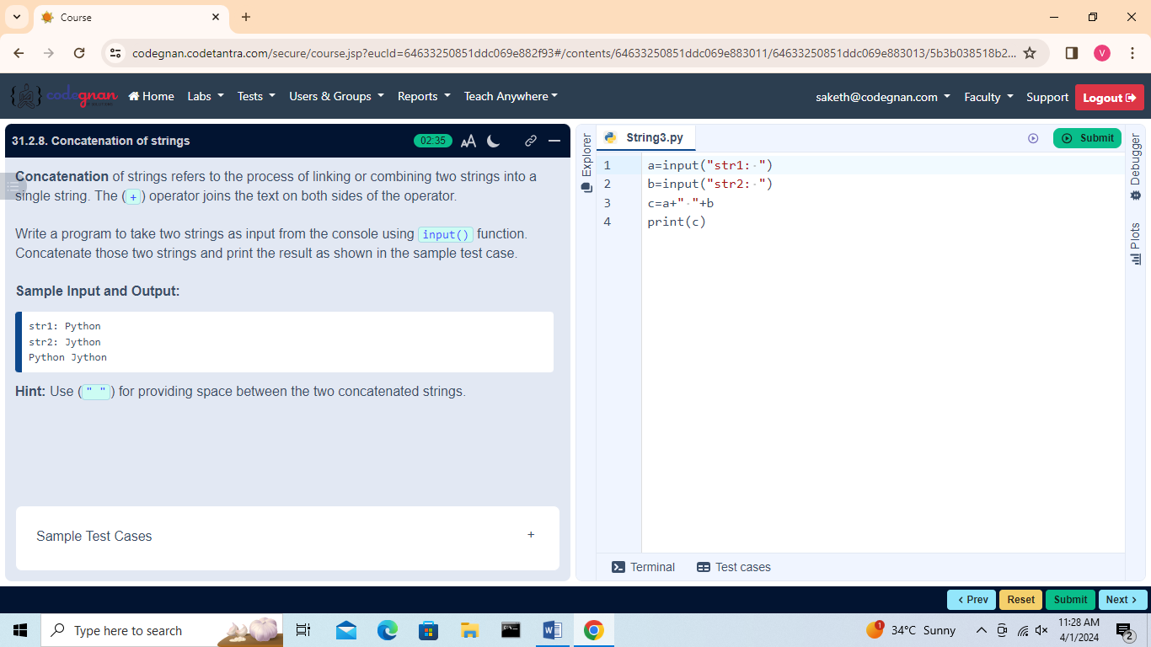

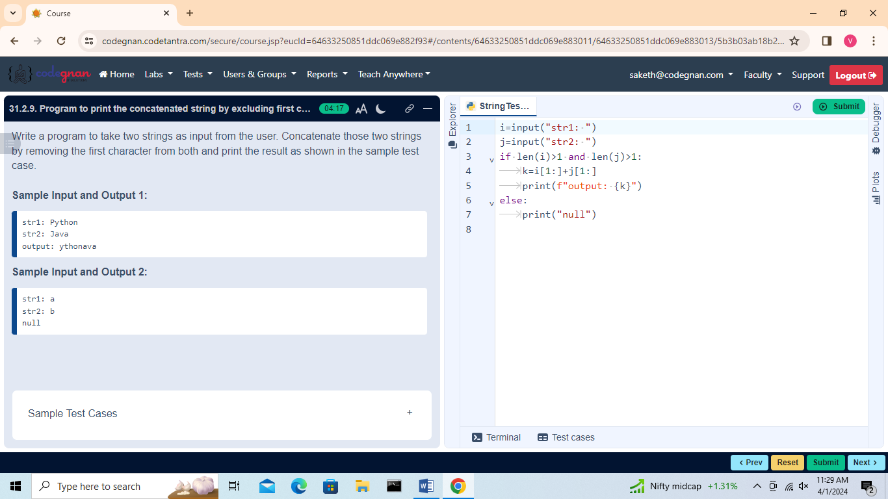

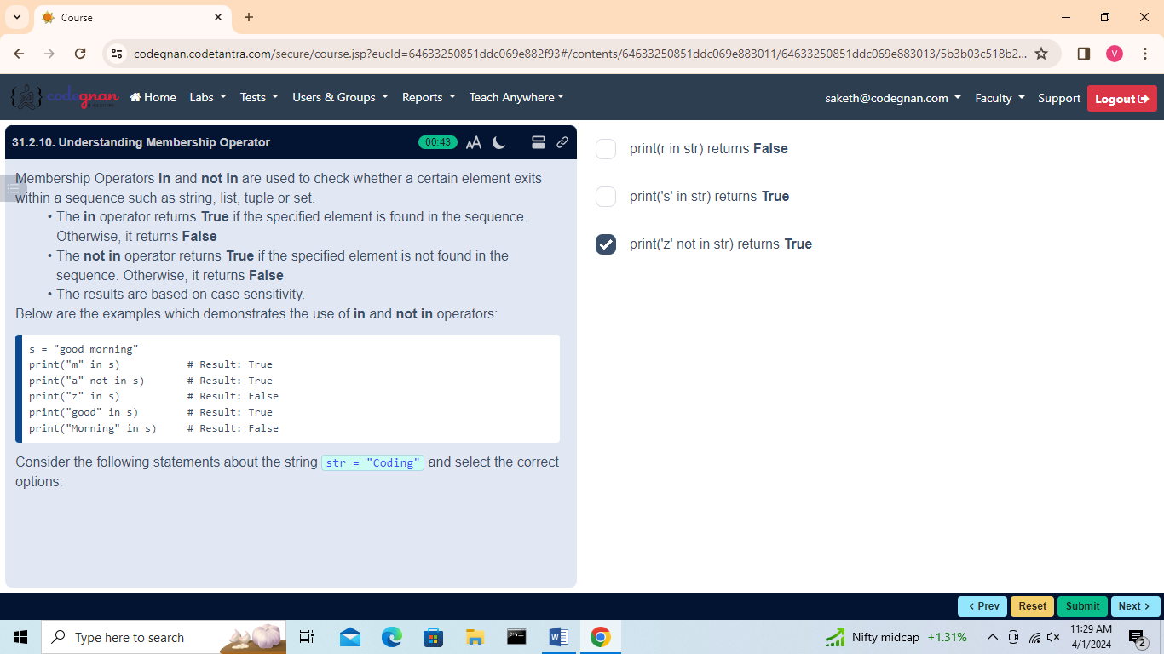

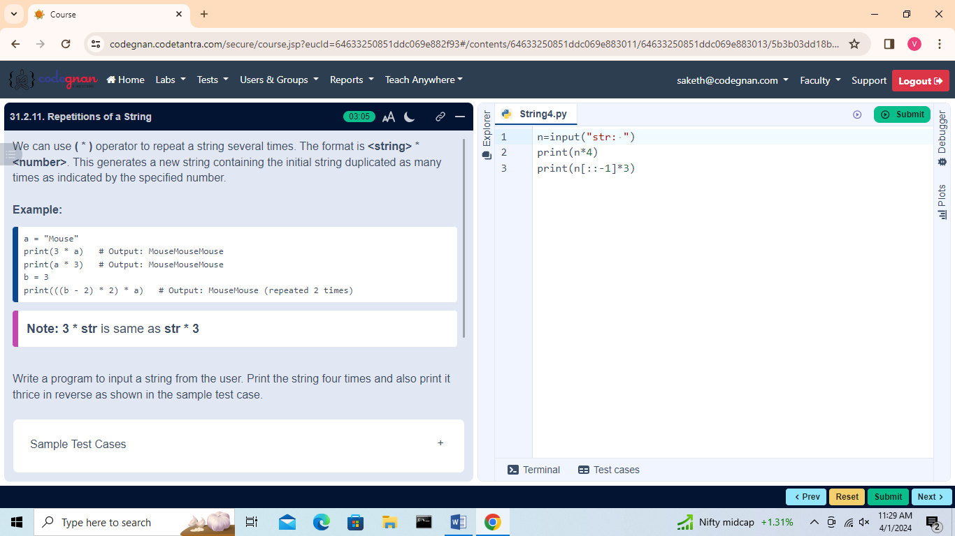

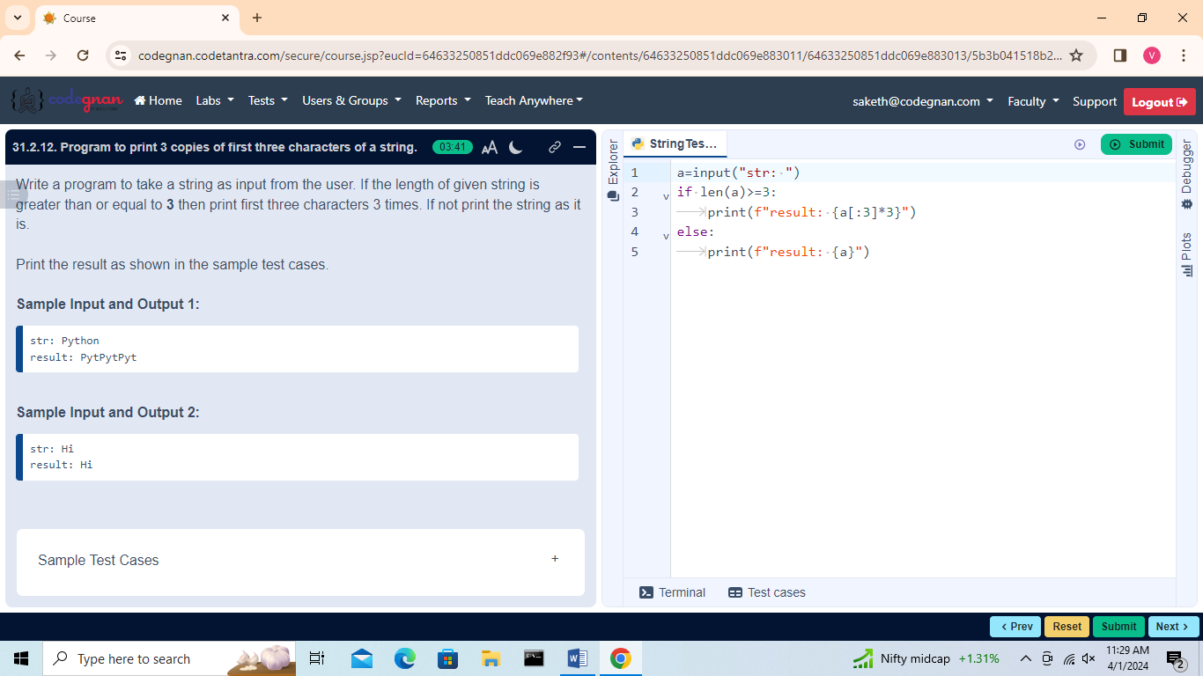

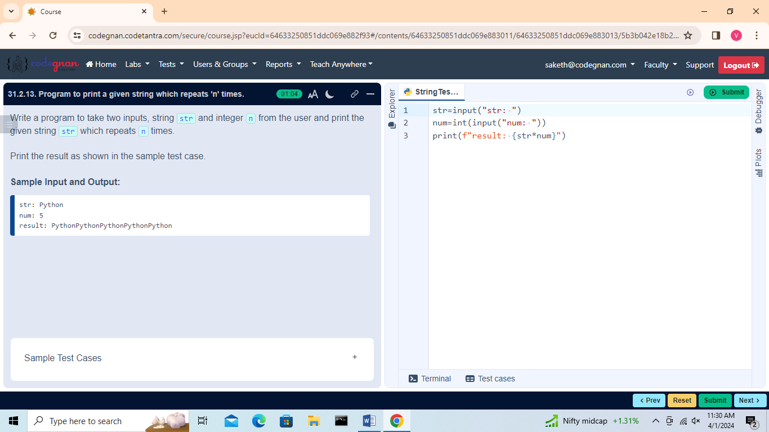

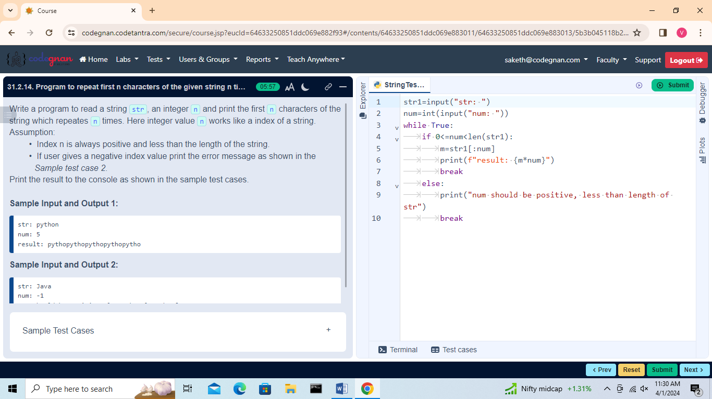

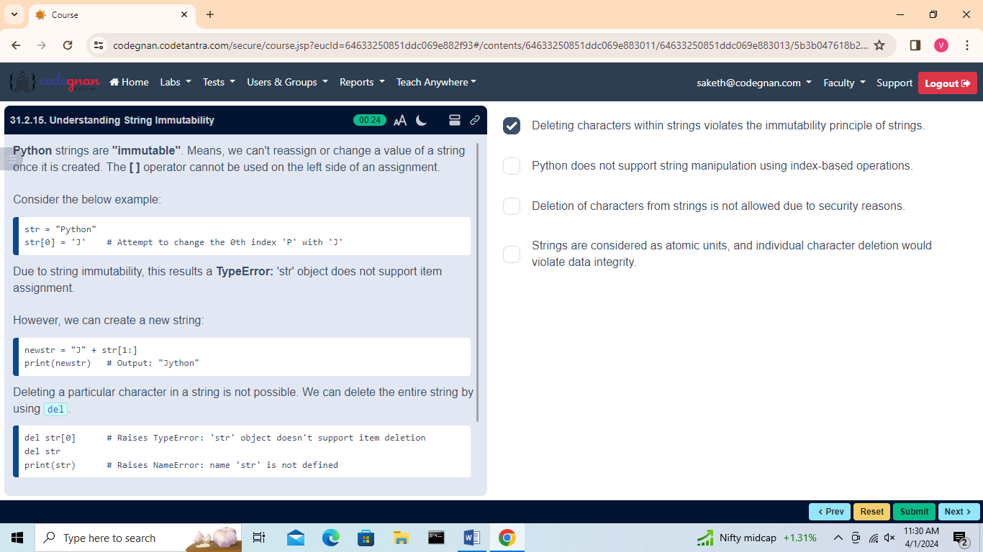

## L32 Built-in String Methods

## 

## 

## 

## 

## 

## 

## 

## 

## 

## 

## 

## 

## 

## 

## 

## 

## 

## 

## 

## 

## 

## L33

Introduction to Lists

## 

## 

## 

## 

## L34

Basic List Operations

## 

## 

## 

## 

## 

## 

## 

## 

## 

## 

## 

## 

## 

## 

## 

## 

## 

## 

## L35

Built-in List Functions

## 

## 

## 

## 

## 

## 

## L36

List Methods

## 

## 

## 

## 

## 

## 

## 

## 

## 

## 

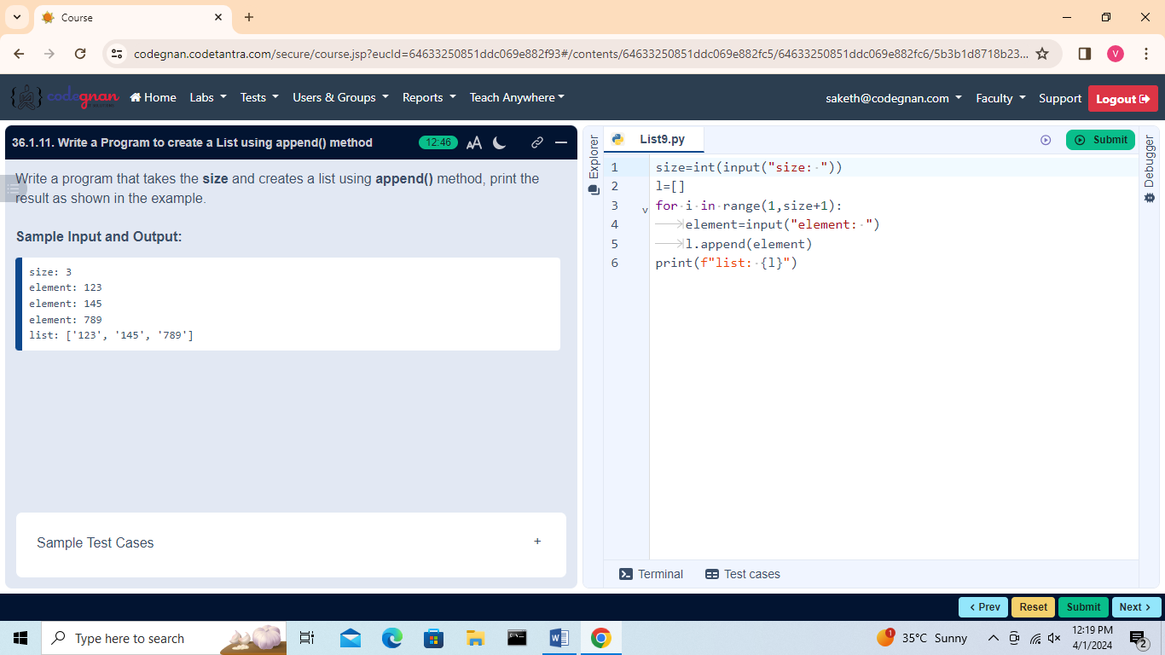

## L37

Introduction to Tuples, Basic Tuples Operations

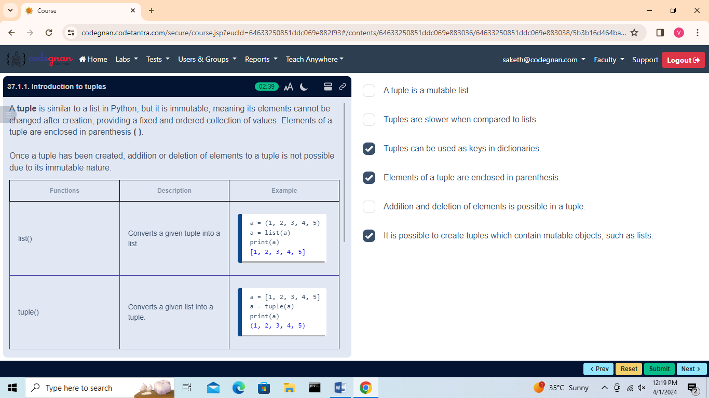

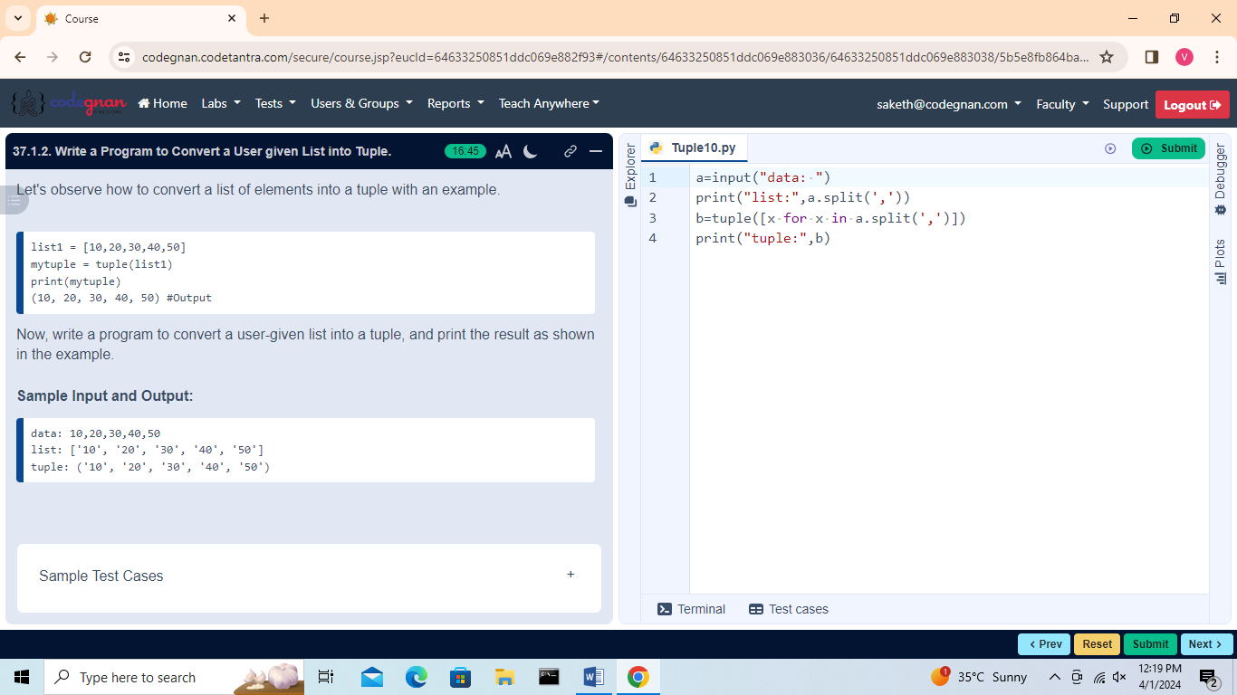

## Basic Tuples Operations

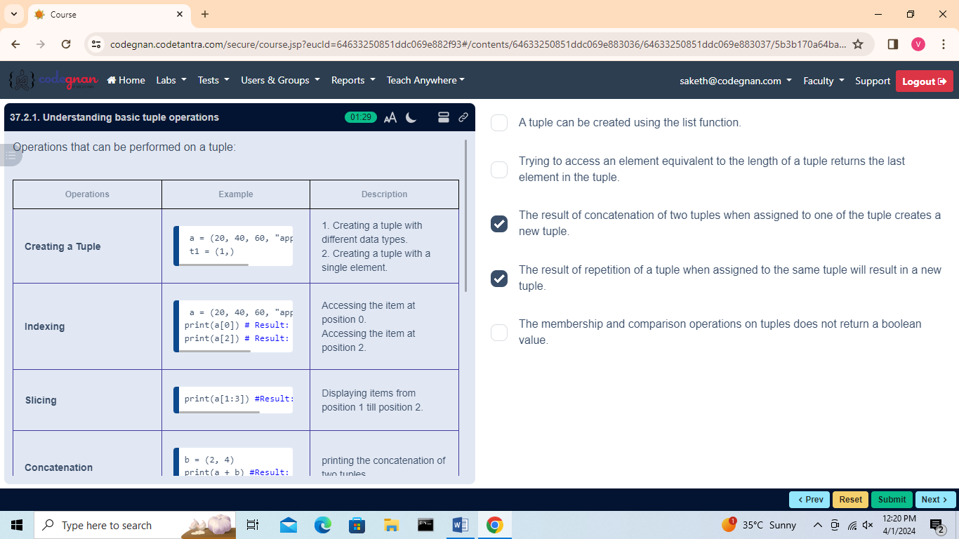

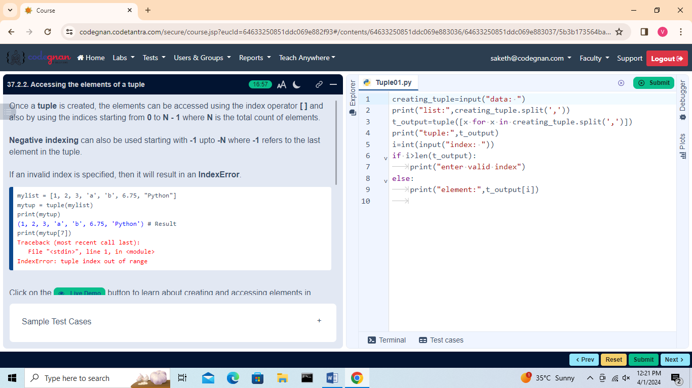

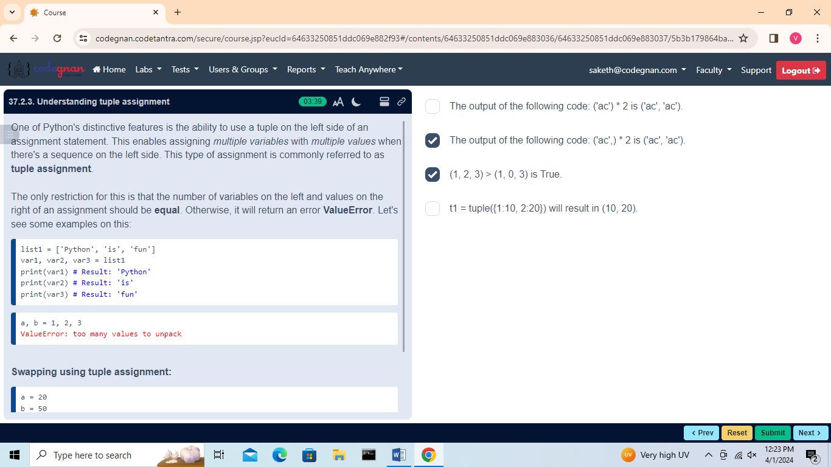

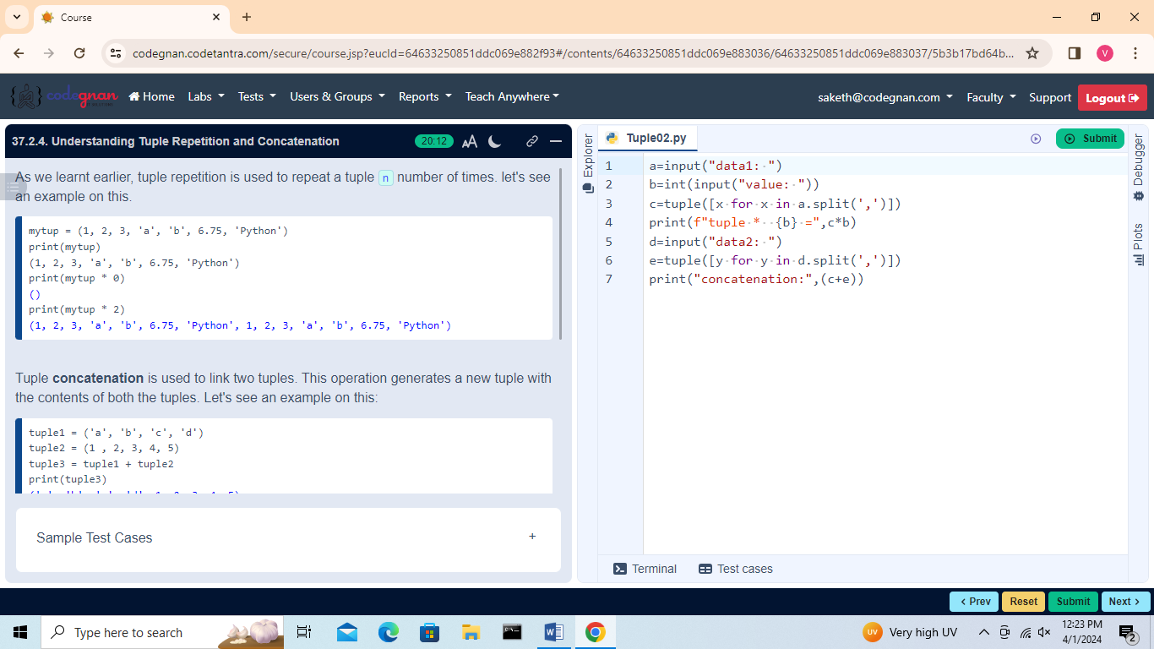

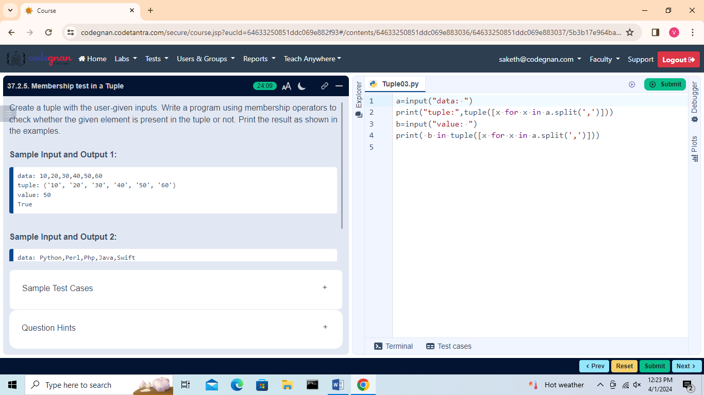

## 

## 

## 

## 

## 

## 

## 

## L38

Built-in Tuple Functions

## 

## 

## 

## 

## 

## 

## 

## 